Design Document

**BPSK Modem with Convolutional Code**

Submitted To:

Professor Dennis Silage

Senior Design Project I and II

Temple University

College of Engineering

1947 North 12th Street

Philadelphia, Pennsylvania 19122

March 29, 2014

Prepared By:

PCG

C. Destin, B. Keith, & B. Thibodeau

*Programmable Communication Group*

Faculty Advisor: Dr. Dennis Silage

Temple University

College of Engineering

1947 North 12th Street

Philadelphia, Pennsylvania 19122

For further information, please contact Dr. Dennis Silage (email: silage@temple.edu).

|  |  |  |
| --- | --- | --- |
| **Team SD1-01** | **Programmable Communication Group** | **PCG** |
| **Team Members** | Cedric Destin, Brandon Keith, Brian Thibodeau | |
| **Advisor(s)** | Dennis Silage, PhD | |
| **Coordinator** | Thomas Sullivan, PhD | |
| **Department(s)** | Electrical and Computer Engineering | |
| **Project Title** | BPSK Modem with Convolutional Code | |
| **Abstract** | Amateur radio satellite telemetry is the process of using the amateur radio frequency bands to transmit telemetry data from a miniaturized low-Earth orbiting satellite to a ground station. The most prevalent means of transmitting telemetry data down to Earth is not nearly as power-efficient as it could be. Inefficient power usage makes amateur satellite telemetry an expensive and esoteric hobby to get involved with. This senior design team aims to demonstrate how concatenated forward error correction (FEC) codes can make amateur satellite telemetry more power-efficient, and hence make the hobby more accessible to prospective amateur satellite operators. Specifically, we use FPGA hardware to implement a BPSK modem with a (2,1,7) convolutional encoder and Viterbi decoder. The performance of the proposed modem is evaluated using an AWGN core. | |
| **URL** | <https://sites.google.com/a/temple.edu/programmable-communication-group/> | |

**Executive Summary**

Table of Contents

1. Problem 6

1.1. Overall Objectives 6

1.2. Historical and Economic Perspective 6

1.3. Candidate Solutions 7

1.3.1. Forward Error Correction: Block and Convolutional Codes 7

1.3.2. Line Coding: Non Return Zero and Manchester 9

1.3.3. Carrier Recovery: Squaring Loop and Costas Loop 10

1.3.4. Clock and Data Recovery: Open Loop and Closed Loop Circuits 12

1.4. Proposed Solution Concept 13

1.5. Major Design and Implementation Challenges 13

1.6. Implications of Project Success (Brandon) 14

2. DESIGN REQUIREMENTS 15

2.1. Functional Design Constraints (Brandon K) 15

2.2. Non-Functional Design Constraints (Brandon) 16

3. APPROACH 16

3.1. Software Simulation Using Matlab/Simulink 16

3.1.1. Forward Error Correction: Convolutional Encoder & 2-bit Serializer 16

3.1.2. FEC-BPSK Modulator 18

3.1.3 AWGN Channel 19

3.1.4 FEC-BPSK Demodulator: Carrier, Timing, Data Recovery & Soft-decision Encoding 20

3.1.5 Forward Error Correction: Soft-decision Viterbi Decoding 28

3.1.6 Simulation Results 29

3.2. Hardware Implementation using ISE Project Navigator 30

3.2.1 Serial Terminal Program & Software BER Calculation Script 34

3.2.2 10K-bit Receive and Transit Storage Buffers 35

3.2.3 Forward Error Correction: Convolutional Encoder & 2-bit Serializer 36

3.2.4 FEC-BPSK Modulator 36

3.2.5 AWGN Channel 36

3.2.6 FEC-BPSK Demodulator: Carrier, Timing, Data Recovery & Soft-decision Encoding 36

3.2.7 Forward Error Correction: Soft-decision Viterbi Decoding 36

4. EVALUATION (Brandon) 36

5. SUMMARY AND FUTURE WORK 36

6. ACKNOWLEDGEMENTS 36

7. REFERENCES 37

# Problem

## Overall Objectives

It has been shown that forward error correction can dramatically improve bit error rate performance (BER) in amateur packet radio satellite telemetry links (Hsiao, et. al, 2000). Additionally, it has been shown that binary phase shift-keying (BPSK) modulation is more reliable and bandwidth-efficient than audio frequency shift keying (AFSK) modulation (Hsiao, et. al, 2000). A quick survey of active amateur radio satellites reveals that many of them use FSK modulation and lack forward error correction capabilities. This senior design project aims to demonstrate how BPSK modulation with forward error correction (specifically convolutional coding) makes amateur radio satellite telemetry more accessible and reliable. Consequently, this senior design project advocates for improved robustness in amateur packet radio communication systems, specifically in those systems dealing with satellite telemetry.

Amateur packet radio satellite telemetry is often unidirectional and does not benefit from automatic repeat request (ARQ) like in other bidirectional amateur packet radio communications (Hsiao, et. al, 2000). In other words, if even one bit of an AX.25 telemetry packet is received in error, the entire packet is discarded and cannot be re-transmitted (Karn, 1994). This means that beacon signals from the amateur satellites must be transmitted with enough power to ensure that the embedded telemetry packet is received without error (de Milliano, et. al, 2010). BPSK modulation with convolutional coding outperforms AFSK modulation in terms of BER performance. This fact could benefit amateur radio satellite telemetry by improving network reliability and accessibility. The enhanced network reliability could lower overall power consumption in amateur telemetry satellites (de Milliano, et. al, 2010), resulting in two benefits: 1) reduced cost of satellite construction, and 2) making amateur telemetry satellites more technologically and financially accessible to amateur satellite operators by reducing the size, cost, and complexity of ground station antennas (Karn, 2011).

The ultimate goal of this senior design project is to demonstrate the improved network reliability (in terms of BER) and accessibility (in terms of link margin) that results from implementing BPSK modulation with convolutional coding in amateur packet radio telemetry satellites and ground stations.

## Historical and Economic Perspective

The standard digital modulation scheme used for amateur radio very-high frequency (VHF) and ultra-high frequency (UHF) operation is Bell 202 (Capitaine, et. al, 2010). Bell 202 provides AFSK modulation using 1200 Hz and 2200 Hz tones, with a resulting data rate of 1200 b/sec. It is typically used in the physical layer of the AX.25 data link layer protocol and this has been the case since the early 1980s (Karn, 1994). In 1984, when Bell 202 was a fairly new standard in the amateur radio community, Steve Goode, K9NG, performed an exhaustive bit error rate (BER) performance analysis of a standard Bell 202 modem (Goode, 1984). Goode found that 25 dB SNR at his FM receiver was necessary for high communication reliability. In other words, 25 dB SNR or higher was required to accurately receive 98% of incoming packets, which corresponded to a BER of 1.6e-5. Ralph Wallio, WORPK, figured out that with this BER, there is only a 1.603% chance of accurately receiving 117 consecutive 256-byte AX.25 packets (Wallio). Wallio concluded that “this is as Goode as it gets” and it is virtually impossible to get better results without error correction.

This poor reliability performance is not exclusive to amateur radio terrestrial communications. In 1995, it was demonstrated that error detection (not error correction) alone is not robust enough for amateur radio microsatellite communications (Hsiao, et. al, 2000). Particularly in unidirectional satellite communications, the harsh environmental conditions coupled with the microsatellite’s characteristically low transmitter power make for very unreliable telemetry data links (Hsiao, et. al, 2000). It has been demonstrated that forward error correction, specifically convolutional coding, can generally correct up to 75 percent of errors (Hsiao, et. al, 2000). It was also demonstrated that 1200 b/sec BPSK provides much more reliable transmission quality than 1200 b/sec AFSK, irrespective to whether the VHF or UHF amateur bands are used. Moreover, it was demonstrated that BPSK occupies a considerably smaller frequency bandwidth than AFSK while possessing excellent anti-interference properties. And with a general tenfold BER performance increase for both 1200 b/sec AFSK and BPSK over 144 MHz VHF, implementing forward error correction for amateur satellite telemetry was clearly demonstrated to be better than not implementing forward error correction.

In 2003, the AAU-Cubesat was one of the first pico-satellites to be launched into space. Moreover, the miniaturized satellite harbored a communication subsystem that implemented both forward error correction and interleaving over 9600 b/sec Gaussian minimum shift-keying (GMSK) AX.25 (Alminde, et. al, 2002). The enhanced robustness and data rate was justified by the fact that it had to transmit approximately 1461 kilobytes (kB) of telemetry and picture data per day. This simply would not have been possible had the satellite not utilized error correction. However, it operated at 437.9 MHz, which meant that a 2-meter radio could not receive its telemetry data. This would particularly bother Phil Karn, KA9Q, who is a strong proponent of making robust satellite telemetry links accessible to the average amateur radio operator (Karn, 2011). Karn asserts that robust telemetry links (using forward error correction) reduce the cost of satellite construction and simplify ground antennas, making amateur radio satellite telemetry much more technologically and financially accessible to amateur satellite operators (Karn, 2011).

As amateur satellite designers foresee the next generation of miniature satellites (de Milliano, et. al, 2010), and as the next generation of amateur satellites equipped with robust communication schemes continue to ascend into space, and as miniature satellites become increasingly more financially and technologically accessible to amateur satellite operators, it must be clearly demonstrated to the amateur radio community how these advancements trump the ubiquitous 1200 b/sec AFSK AX.25. Hence, to reiterate, this senior design project hopes to clearly demonstrate the performance advantages that yield from using BPSK modulation with forward error correction in amateur satellite telemetry.

## Candidate Solutions

Basic functions of a telemetry modem include baseband modulation/demodulation (line codes), passband modulation/demodulation, synchronization, and forward error correction. In the last century, many solutions have been proposed that trade performance in terms of bandwidth, transmission power and complexity. In this section we consider the following solutions:

1. Two forward error correcting codes - block codes and convolutional codes.
2. Two line codes – Non-Return to Zero (NRZ) and Manchester code.
3. Two carrier recovery circuits – Costas Loop and squaring loop.
4. Two timing and data recovery circuits – open loop and closed loop (Early-Late gate).

The subsequent sections will consider the costs and benefits of the aforementioned solutions.

### Forward Error Correction: Block and Convolutional Codes

Forward error correction (FEC) is a form of robust channel coding. It is used to correct errors that are injected into a digital communication link across a noisy propagation medium (channel). FEC codes fall into two general categories: block codes and convolutional codes.

NOTE: *At the time of writing this document, the Xilinx CORE Generator in Project Navigator ISE 14.6 only consists of one block coder/decoder pair and one convolutional coder/decoder pair. The block coding pair consists of a Reed-Solomon coder and decoder. The convolutional coding pair consists of a convolutional encoder and a Viterbi decoder.*

Deep space and satellite communication links are riddled with random errors across a very wide bandwidth (Nguyen, et. al, 2009). In addition to random errors in the satellite link, bursts of noise can corrupt an entire segment of a link resulting in burst errors (Murphy, et. al, 1994). Block codes are better suited for correcting burst errors while convolutional codes are better suited for correcting random errors (Viswanathan, 2013). A combination of block codes and convolutional codes, namely concatenating codes, are used in many systems to provide robustness against both kinds of errors (see Figure 1.a). This concatenating code consists of a coding chain and a decoding chain. The coding chain resides in the transmitter and consists of a Reed-Solomon encoder, followed by a block interleaver, then a convolutional encoder. The decoding chain resides in the receiver and undoes what the coding chain did. Namely, the decoding chain consists of a Viterbi (convolutional) decoder, followed by a block de-interleaver, then a Reed-Solomon decoder.

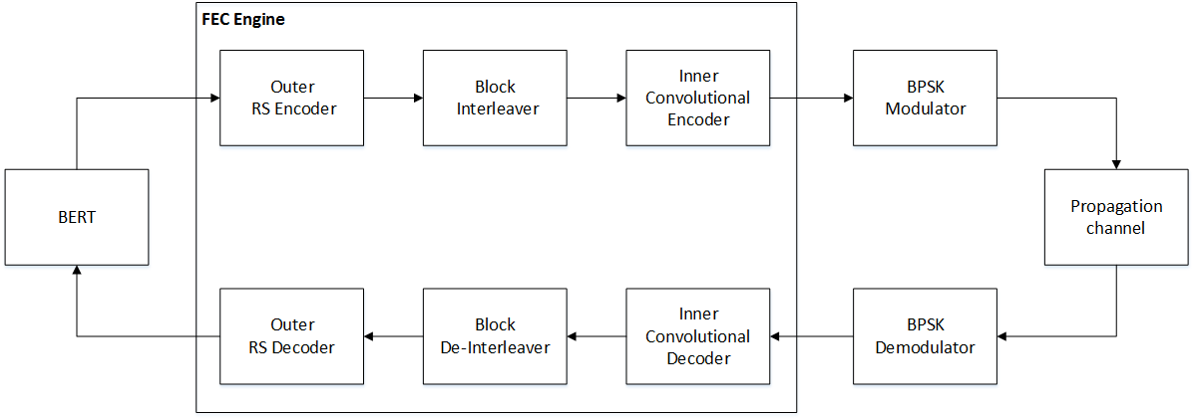

Figure 1.a Simplified top-level diagram for a concatenating code scheme consisting of a block code pair, an interleaving pair, and a convolutional code pair.

The propagation medium for space communications is modeled well by the AWGN channel (Viswanathan, 2013). Furthermore, it is understood that AWGN provides maximum bit corruption and compared to other channel models, systems that perform the best in AWGN perform the best in real-life situations (Viswanathan, 2013). Hence, this senior design project will rely solely on the AWGN channel to represent our propagation medium.

Figure 1.b shows the propagation medium being modeled by the AWGN channel. The AWGN channel is a random noise channel, not a bursty noise channel. Being that convolutional coding excels at correcting random errors, it is logical that convolutional coding alone pairs well with the AWGN channel. Therefore, convolutional coding is the only forward error correction scheme used in this senior design project (shown in Figure 1.b).

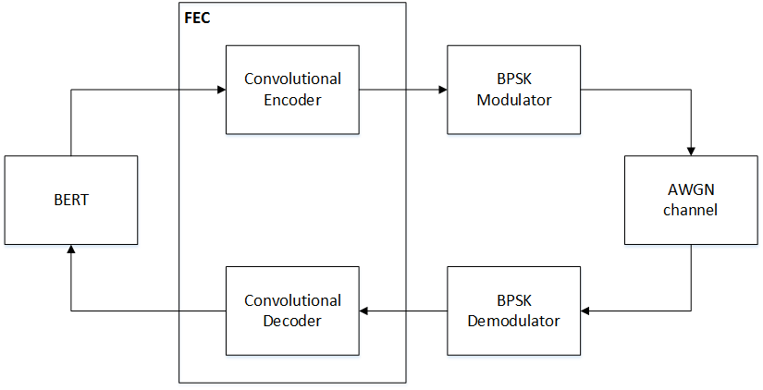

Figure 1.b Simplified top-level diagram for a BPSK modem using a convolutional coding scheme for forward error correction. An AWGN channel is used as the propagation medium due its sufficiency in modelling space communication links. Convolutional coding is used to correct the random errors that result due to the random noise of the AWGN channel.

### Line Coding: Non Return Zero and Manchester

There are three criteria used for evaluating the performance of line codes: interference and noise immunity, bandwidth, and synchronization capabilities. These criteria are used for determining the appropriate line code that should be used in modems. NRZ is the most common line code as it appears naturally in digital logic. A binary one ($b_{1}$) is represented by a positive voltage while a binary zero ($b_{0}$) is represented by zero voltage. Conversely, Manchester line code represents a ‘ $b_{1}$’ by a transition from zero volts to a positive voltage during the second half of the bit period while a ‘ $b_{0}$’ is encoded as a transition from a positive voltage to zero volts during the first half of the bit period. Compared to NRZ, this means that Manchester code has two level transitions during one bit period while NRZ has only one. This presents a tradeoff between NRZ and Manchester in terms of synchronization and bandwidth. The two level transitions during each bit period means that the receiver can easily extract the transmitted clock to use for synchronization between the transmitter and receiver. The tradeoff is an increase in bandwidth due to the more frequent transitions, but how do these line codes perform in a noisy environment? The simple answer is that they perform the same. It can be shown that the energy, *E*, in NRZ and Manchester is $V^{2}T_{b}$, where $T_{b}$ is bit period. It can also be shown that each line code has a theoretical probability of bit error to be:

$$P_{b}=Q\left(\sqrt{\frac{2E}{N_{o}}}\right) , ( SEQ Equation \backslash * ARABIC 1)$$

Since NRZ and Manchester share the same theoretical probability of bit error and contain the same energy, they both perform equally likely in a noisy environment. Thus the decision for choosing NRZ or Manchester resides in what is more important, bandwidth or synchronization? Considering our modem requires only a 1200 b/sec data rate, it was decided that synchronization was more important than bandwidth. Thus Manchester code was chosen as the line code in our modem.

### Carrier Recovery: Squaring Loop and Costas Loop

The modem demodulator is responsible for providing either coherent or non-coherent demodulation. Coherent demodulators require phase synchronization between the received signal and the locally generated oscillator. Conversely, Non-coherent demodulation does not require synchronization and makes no attempt to estimate the phase of the received signal. The advantage of non-coherent modulation is that it does not require additional hardware like phase-locked loops which are used to lock onto the incoming carrier phase (Feigin, 2002). However, the LEO-AMSAT’s we are interested in communicating with use BPSK for downlink and thus requires the design of a coherent demodulator.

The successful extraction of information from a received signal in a coherent demodulator requires both carrier and timing synchronization. Figure 2 illustrates the architecture of a typical coherent demodulator.

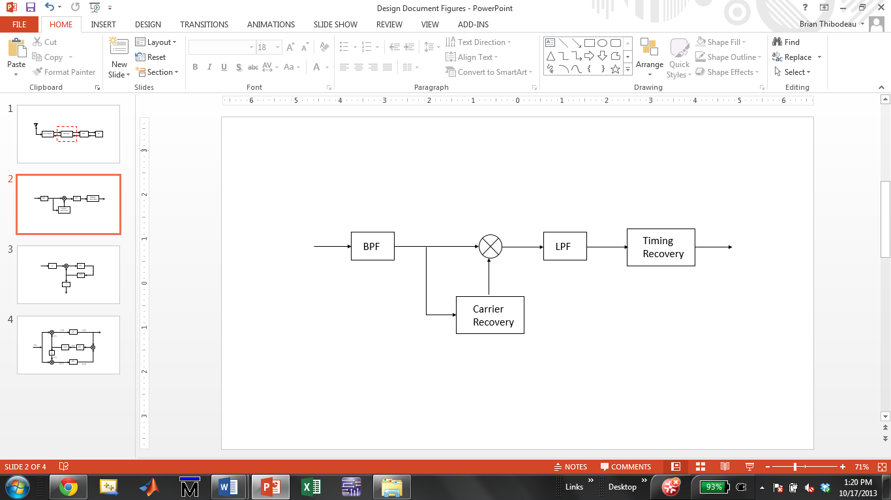

Figure 2. Received waveform takes two paths. First path extracts carrier for coherent demodulation and the second path recovers timing information. This architecture is based on the optimum binary receiver

The received signal from the transceiver is first processed by a band-pass filter to remove as much noise as possible and then sent to the carrier recovery circuit. Recovering the carrier is done in one of two ways, the squaring loop or the Costas loop. Each method utilizes phase-lock concepts and has its own advantages and disadvantages in terms of complexity and performance.

**Carrier Recovery using Squaring Loop**

The squaring loop is a popular choice for coherent demodulation of BPSK waveforms because it is mathematically easy to analyze and its hardware implementation is not as complex as the Costas loop. The squaring loop takes advantage of the fact that when the BPSK signal is squared, the phase offsets are removed leaving only a spectral component at twice the carrier frequency. A bandpass filter isolates the spectral component while also serving to remove any extraneous noise products resulting from the squaring. Following the band-pass filter, the signal is fed to a phase-lock loop (PLL) for phase and frequency tracking. Once the output of the voltage controlled oscillator (VCO) is locked in phase and frequency with the received signal, its frequency is divided by two. The resulting carrier is fed back to the correlator where it is mixed with the received BPSK waveform and the timing can be recovered (Nguyen & Shwedyk, 2009). The operation of the squaring loop is shown in Figure 3.

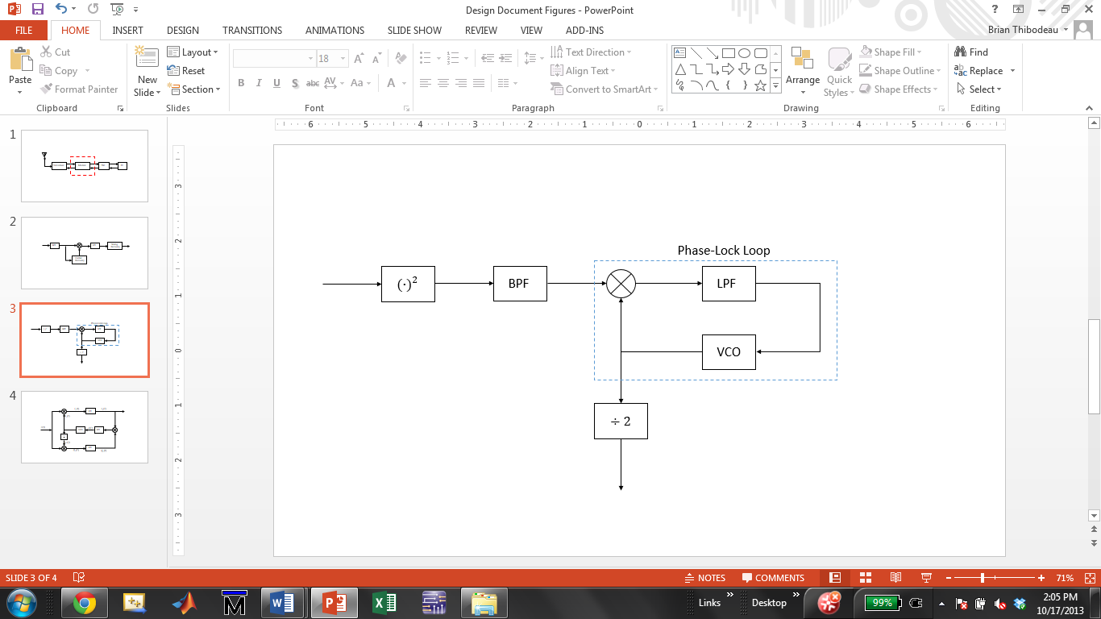

Figure 3. Squaring loop used for carrier recovery in the coherent demodulator. The Phase-Lock Loop utilizes feedback to track and lock onto in the received waveforms suppressed carrier

**Carrier Recovery using Costas Loop**

The second method for carrier recovery is the Costas Loop. Unlike the squaring loop whose only purpose is suppressed carrier reconstruction, the Costas loop is capable of synchronous data detection in addition to suppressed carrier reconstruction (Feigin, 2002). The received BPSK signal takes two paths in the Costas loop, the in-phase loop (top of Figure 4) and the quadrature loop (bottom of Figure 4). Unlike the PLL in the squaring loop, the Costas PLL uses an orthogonal carrier in the quadrature loop which allows direct demodulation of the BPSK signal without a need for squaring. The demodulated symbols are extracted from the in-phase arm once the loop is locked. This is illustrated in Figure 4.

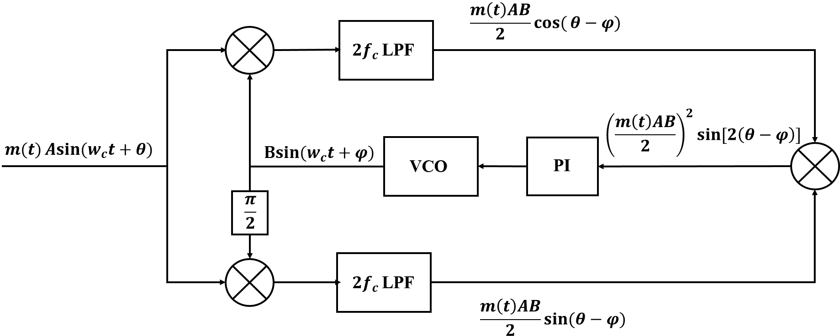

Figure 4. Costas loop used for suppressed carrier reconstruction as well as synchronous data detection.

Following a thorough analytical and experimental analysis of both the Costas loop and squaring loop in Simulink, it was decided that the Costas loop would be implemented for carrier recovery. The squaring loop demonstrated poor BER results as compared to the Costas Loop and the PLL proved unreliable to frequency steps and random 180 degree shifts. Alternatively, the Costas Loop demonstrated superior BER results and more reliable and robust carrier tracking to both phase and frequency steps (see appendix A). One of the downsides of the Costas loop is implementation of the arm filters. If these filters are not perfectly matched, then the loop’s performance is degraded. However, high speed digital circuits like FPGA’s allow the design and implementation of identical filters thus alleviating the problem.

### Clock and Data Recovery: Open Loop and Closed Loop Circuits

Timing recovery is the process of extracting a clock from the received signal so that the correct symbol determination can be made. The reason for this can be understood by recognizing that the local clock at the receiver is not synchronized with the transmitter clock and does not know when to sample the received data in order to make the correct symbol determination. In this section we consider two non-data aided architectures used for timing recovery. The first is an open loop architecture which is shown in Figure 10 (top) and the second is a closed loop architecture shown in 10(bottom). The closed loop circuit under consideration is also known as the Early-Late Gate.

In both methods it is assumed that the received signal is baseband and contains no spectral component. Thus the problem is similar to carrier phase recovery in BPSK. In the open loop method, a spectral component is created by delaying the received signal by one half a bit time and then multiplying it with the original received signal. The result of the multiplication produces a spectral component at a rate of ${1/T}_{b}$ Hz. Then a simple band pass filter can be designed to isolate the desired spectral component. Although simple to implement, the problem with the open loop method is that there is an average non-zero tracking error that reduces system performance (Nguyen & Shwedyk, 2009).

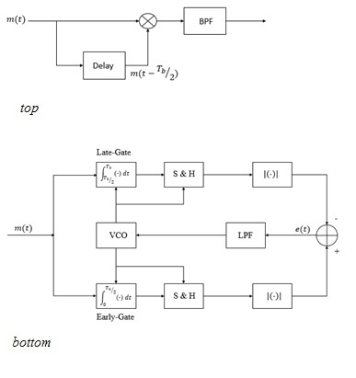

Figure 5. Open loop clock recovery circuit that produces a spectral component at 1/ $T_{b}$.

The non-zero tracking error and be eliminated by using a closed loop timing circuit instead. The Early-Late gate is one closed loop circuit that requires three samples during each bit period. If *m(t)* is the received baseband signal from the correlator, then the early gate integrates and samples *m(t)* early while the late gate integrates and samples the *m(t)* late. The absolute value of the early and late samples are then compared to generate an error. The error signal drives a VCO which advances or retards the clock until the error is zero (Judd, 1996). When the error is zero, the output clock from the VCO is used to sample the received signal at the optimal time needed for correct symbol determination. Since the Early-Late gate synchronizer results in zero error, this method was chosen for timing recovery in our modems. A more detailed analysis of its operation is discussed in the Section 3, Approach.



Figure 6. Architecture for the open- loop timing recovery (top) and the closed- loop (bottom)

## Proposed Solution Concept

This senior design project will consist of developing a software simulation (Simulink) and a hardware implementation (FPGA) of a 1200 b/sec FEC-BPSK modem (using soft-decision) with a (2, 1, 7) convolutional code. Synchronization in the demodulator is accomplished using the Costas Loop carry recovery circuit and the Early-late gate timing and data recovery circuit. We will gather measured BER performance data from the software simulation and the hardware implementation and compare it to the theoretical BER performance. When the measured and theoretical BER performances match closely, the software simulations and hardware implementations will be considered complete. The FPGA hardware implementation is expected to be the most important product of this senior design project.

In addition, we will perform a budget link analysis of our proposed modulation scheme along with two conventional Amateur Radio satellite modulation schemes – AFSK and BPSK. The purpose of the link analysis is to compare the accessibility (in terms of link margin) of Amateur Radio satellite telemetry links when AFSK, BPSK, and FEC -BPSK are received by a “less capable” ground station (e.g. FunCube satellite dongle).

## Major Design and Implementation Challenges

The BER performance analysis of our FEC-BPSK modem is dependent upon the accessibility of an AWGN channel. Although Simulink provides an AWGN channel for the software BER analysis, Xilinx does not currently support an AWGN IP core to be used for our hardware analysis. Xilinx has discontinued their AWGN Core v1.0 since the release of ISE Design Suite 11 (Xilinx, 2009). Consequently, we must find and use an AWGN core outside of the Xilinx product line.

The Costas loop carrier recovery circuit is expected to track and lock onto the transmitted carrier frequency under severe SNR conditions. Thus a major challenge is to design a robust Costas Loop that is capable of tracking changes to both phase and frequency offsets. This is traditionally accomplished using feedback control system concepts, but the Costas Loop (along with the conventional PLL) exhibit highly nonlinear behavior that make modeling a difficult task. However the Costas Loop can be linearized in terms of the phase using small angle approximations. It is important to note that the loop’s behavior to large phase and frequency offsets requires extensive simulation to ensure the desired response is achieved and stability is maintained. Similar design challenges exist for the Early-Late gate circuit as it is also a feedback control system.

The transition from floating-point arithmetic between software simulation and hardware implementation may prove to be troublesome. We understand that there is the **float** data type available in Verilog, but we will be careful to gauge whether results differ widely between software and hardware implementations due to this use of floating-point types.

## Implications of Project Success (Brandon)

It was hinted in Section 1.1 (Overall Objective) and Section 1.2 (Historical Perspective) that this senior design team has identified a problem within the amateur radio community. According to amateur radio operator Jeff Davis, KE9V, amateur radio has somewhat of a *lost future* (Davis, 2010). In the earlier half of the 20th century, amateur radio operators led the forefront of “discovery and experimentation” in the industries of electronics and communications. This was the case because many amateur radio operators were in fact professional electronics technicians and electronics engineers that designed and implemented the next wave of commercial and military communications. Oftentimes, the budding amateur radio operator, a *neophyte* if you will, would go on to become the next electronics repairman or electronics engineer. However, Davis highlights the fact that at some point in the past, the amateur radio community reached somewhat of a crossroads. Up to that point in time, the amateur radio community had pioneered Frequency Modulation (FM) communications over ultra-high frequency (UHF) and very-high frequency (VHF) operations, stationed repeaters throughout the land for long-distance over-air communications, and launched amateur radio satellites into the heavens which led to improved methods for space communications in addition to low-cost spacecraft manufacturing and launch. Davis highlights the fact that although the non-amateur world would go on to produce cellular technology, drastically improved over-air communications, and intelligent military digital communications, the amateur radio community as a whole decided to dwell in the past as the future marched ahead without it.

This senior design team identified one amateur radio operator and notable electrical engineer, Dr. Phil Karn, KA9Q, in his efforts to secure the future of amateur radio. Like Jeff Davis, Dr. Karn is also aware of amateur radio’s *lost future*. In a modem design article (Karn, 2011), Dr. Karn hints that making amateur radio communications more accessible to prospective amateur radio operators is one solution for securing the future of amateur radio. Specifically, in the design article, Karn identifies the fact that amateur radio satellite communications is mostly inaccessible to amateur radio operators because the equipment involved is too expensive and esoteric. Karn’s philosophy is that by making amateur radio satellite communication accessible to all amateur radio operators, school demonstrations will be more commonplace and consequently more kids will want to become amateur radio operators. It is implied that if more kids become amateur radio operators, or *hams*, amateur radio in general cannot have a *lost future*.

Hence, according to Phil Karn, one solution to securing the future of amateur radio is to make amateur radio satellite communications more accessible to kids. In order to make amateur radio satellite communications more accessible to kids, the amateur radio equipment involved in said communications must be less expensive and esoteric. By expensive and esoteric, Karn is referring to state-of-the-art software-defined radio systems and bulky antennas. This kind of equipment is regarded as being too inaccessible for the typical school demonstration of amateur radio satellite communications. Instead, Karn emphasizes the fact that a standard 2-meter single sideband (SSB) transceiver and an inexpensive antenna system should be all that is required at these school demonstrations. Satellite communications in general requires for relatively high-powered transmission of signals to overcome the high fading (energy loss) that results from an electromagnetic wave propagating through space (Sklar, 2001). In fact, free space attenuates an electromagnetic wave more than any other form of power attenuation along a satellite communication link. Hence, it is often the case that transmitted signals between amateur packet radio satellites and ground stations either deal with high transmission power to acquire a digital communication link with high data reliability or lower transmission power and low data reliability and link efficiency. It is understood that if you increase the reliability (BER) of a communication link, you can communicate with less capable ground stations (de Milliano, et. al, 2010). “Less capable” ground stations includes stations with small, portable SMA antennas and little USB modem dongles (e.g. FunCube dongle). Consequently, amateur radio satellite communications could become more *accessible* to prospective amateur satellite operators.

In a similar fashion as Phil Karn, KA9Q, and others (Hsiao, 2000), this senior design project aims to demonstrate that there are much more reliable digital communication schemes than are currently employed in most amateur radio satellites today. The intention of this senior design project is to provide concrete evidence that BPSK modulation with forward error-correcting codes can make amateur radio satellite communications more reliable and hence, more *accessible* to prospective amateur satellite operators. Perhaps budget link analyses of popular and prospective communication schemes, like showcased in this senior design project, would further persuade an amateur satellite designer to employ more reliable communication schemes in the ascending fleet of miniaturized amateur radio satellites.

# DESIGN REQUIREMENTS

As discussed in the section 1.4 (Proposed Solution Concept), our analysis will require the design and implementation of a 1200 b/sec FEC-BPSK modem with a (2, 1, 7) convolutional code. The functional requirements of this system are summarized in Table 1 in section 2.1 followed by a summary of each. Non-functional requirements are listed in Table 2 in section 2.2.

## Functional Design Constraints (Brandon K)

|  |  |
| --- | --- |
| **Name** | **Description** |
| Data Rate | The convolutional encoder is required to receive user data at a rate of 1200 b/sec.  The convolutional encoder is required to transmit FEC data at a rate 2 x 1200 = 2400 b/sec.  The BPSK modulator is required to receive serialized FEC data at a rate of 0.5 x 2400 b/sec = 1200 b/sec.  The BPSK demodulator is required to deliver 3-bit soft-decision data at a rate of 3 x 2400 b/sec = 7200 b/sec.  The Viterbi decoder is required to receive 3-bit soft-decision at a rate of 3 x 1200 = 3600 b/sec.  The Viterbi decoder is required to deliver user data at a rate of 1200 b/sec. |
| Symbol Rate | The BPSK modulator is required to operate at 2400 symbols/sec.  The BPSK demodulator is required to operate at 2400 symbols/sec. |
| Line Coding | Manchester Encoding is resilient to small changes in Frequency due to Doppler shift and provides easier clock extraction during demodulation. |
| Modulation/ Demodulation | BPSK modulation is done non-coherently and BPSK demodulation is done coherently. 3-bit soft-decision encoding is implemented in the output of the demodulator. |
| Operating Frequencies | The BPSK modems will modulate the data using a 4800 Hz carrier. |
| BER Performance  (Eb/N0 dB)  (over AWGN) | 0.5 @ 0 dB  0.0783 @ 1 dB  0.0071 @ 2 dB  4.28e-4 @ 3 dB  1.74e-5 @ 4 dB  4.40e-7 @ 5 dB |
| Forward Error Correction | This modem will use the (2, 1, 7) convolutional code. Viterbi decoding will operate in 3-bit (fixed point) soft-decision decoding mode. |
| Interface(s) | Modified 19-bit AWGN core (Verilog)  BERT: RS-232 (1200 b/sec, 1 parity bit, 1 stop bit, no flow control) |

Table 1. Functional design constraints for the all three systems.

## Non-Functional Design Constraints (Brandon)

These non-functional design constraints are based off of the Trenz Electronics Micromodule Spartan-6 XCSLX45-2CSG484I FPGA development board (product#: TE0630-00I) and Trenz Electronics Demo Carrier Board for Industrial Micromodule TE0300/TE0630 (product#: TE0304-00).

|  |  |  |
| --- | --- | --- |
| **Type** | **Name** | **Description** |
| Economic | Cost | FPGA Board: $204.64, Carrier Board: $81.03 |
| Environmental | Temperature | FPGA Industrial grade: -40° C to 100° C |
| Environmental | Power Consumption | Carrier Board: USB bus power supply |
| Manufacturability | Dimensions | Carrier Board: 115 x 79 mm |
| Manufacturability | Weight | < 1 lb. |

Table 2. Non-functional design constraints for test board.

# APPROACH

## Software Simulation Using Matlab/Simulink

Simulink provides a graphical design environment for rapid prototyping and simulation of the various subsystems and circuits required by the FEC-BPSK modem. Each system, subsystem, and circuit was designed using a black box approach. Not only does this allow seamless integration of our individual designs, but it also helps organize the design modularly to be carried over to FPGA. In addition, Simulink provides the tools and block sets necessary to evaluate the performance of our system under a variety of conditions. Of particular importance is the evaluation of BER performance in AWGN and phase and frequency shifts. These are conditions that all modems are expected to able to handle.

The remainder of the section is organized as follows: section 3.1.1 will consider transmitter-side of the forward error correction scheme. That is, the (2, 1, 7) convolutional encoder and required 2-bit serializer will be discussed. In section 3.1.2, the modulator subsystem is discussed. Then in 3.1.3, the demodulation subsystem of BPSK is discussed by examining Costas Loop carrier recovery circuit and the Early-Late gate timing and data recovery circuit. Closely related to PLL is the early-late gate synchronizer which is used for timing recovery of both modems. Its Simulink design will also be discussed in section 3.1.3. Lastly, section 3.1.4 will conclude the Software simulation section by examining soft-decision Viterbi decoding and how it can be used to reduce the BER of the BPSK modem.

### Forward Error Correction: Convolutional Encoder & 2-bit Serializer

The convolutional encoder holds *k* bits of input data (*k-*bit message word) to generate an *n*-bit output. A constraint length *K* represents how many *k-bit* message words are used to process the *n-bit* output of the convolutional encoder. This would be regarded as a (*n*, *k*, *K*) convolutional encoder. The convolutional encoder is composed of a shift register with *K* *k-bit* stages and *n* modulo-2 adders. As an example, Figure 41 shows a (2, 1, 7) convolutional encoder. In fact, the (2, 1, 7) convolutional code will be used solely throughout this senior design project. The (2, 1, 7) convolutional encoder comprises *K = 7* stages (or, *K – 1* = 6 *k*-bit delays) in its shift register and *n* = 2 modulo-2 adders. Each stage of the shift register holds *k* = 1 bits. The *code rate* of a convolutional encoder is *k/n*, so the code rate for this encoder is ½.

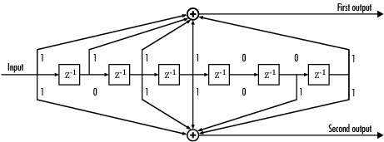

Figure 41. (Courtesy of Matlab®) A convolutional encoder (1/2 code rate, constraint length 7).

At each unit of time, *k* bits will shift to the next stage in the shift register, and *k* bits will shift into the first stage of the shift register. There are *K* stages for a group of *k* bits to shift into before it eventually shifts out of the shift register. At each unit of time, each of the *n* modulo-2 adders are sampled and these *n* bits are outputted by the convolutional encoder. In Figure 41, the top modulo-2 adder provides the first output bit and the bottom modulo-2 adder provides the second output. These two bits combined are the output of this convolutional encoder. Hence, one bit shifts into the encoder and two bits are produced by the encoder. The connections between the shift register stages and the modulo-2 adders, or the *generation matrices*, characterize the convolutional encoder. In other words, some permutations of connections have better error-correcting capabilities than other permutations of connections (Sklar, 2001).

The *trellis diagram* is widely used for showing the possible outputs of a convolutional encoder. However, in the case of the (2, 1, 7) convolutional encoder, the trellis diagram would compose 64 (2K-1 = 27-1) states. Consequently, it would not be practical or possible to display the full trellis diagram in this report. However, as a basic example, let’s see how the convolutional encoder (shown in Figure 41) would process the following:

In the convolutional encoder: 11010002

1st output: (12 + 12 + 02 + 12 + 02) % 2 = 12

2nd output: (12 + 02 + 12 + 02 + 02) % 2 = 02

2-bit output: 012

The *poly2trellis* function is used by Simulink to generate the functionality of the *Convolutional Encoder*. Hence, the command **poly2trellis(7, [171 133])** was entered in the *trellis structure* parameter field. The argument is interpreted as a convolutional encoder with constraint length 7 and whose generation matrices (or shift register connections) are described in octal code. The upper generation matrix is 1718 and the lower generation matrix is 1338. This can be verified by studying the connections shown in Figure 41.

It is now understood that the output of the (2, 1, 7) convolutional encoder is a 2-bit value. It is required that this 2-bit value be serialized before passing on to the BPSK modulator (which implements 1-bit modulation). Hence, an *Unbuffer* block is used at the output of the convolutional encoder for this very purpose.

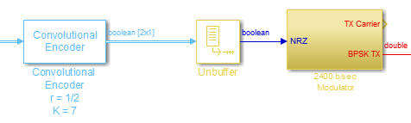

### FEC-BPSK Modulator

In PSK, each bit corresponds to a distinct phase of a sinusoidal carrier. For BPSK, these phases are chosen to be 0 and 180 degrees with the transmitted signal $s(t)$, represented mathematically by equation (6).

$$s\left(t\right)=\left\{\begin{aligned}A\sin\left(2πf_{c}t\right), logic '1' \\ A\sin\left(2πf_{c}t+π\right), logic '0'\end{aligned}\right. . ( SEQ Equation \backslash * ARABIC 2)$$

Then exploiting the fact that $\sin\left(2πf_{c}t+π\right)=-\sin\left(2πf_{c}t\right)$, the expression for the transmitted BPSK can be re-written as:

$$s\left(t\right)=\left\{\begin{aligned}A\sin\left(2πf_{c}t\right), logic '1' \\ -A\sin\left(2πf_{c}t\right), logic '0'\end{aligned}\right. , ( SEQ Equation \backslash * ARABIC 3)$$

where $A$ is the Amplitude and $f_{c}$ is the carrier frequency of the transmitted BPSK signal. From equation (7), the Simulink model of the BPSK modulator was designed to modulate a 2400 b/sec NRZ data stream by gating two antipodal sinusoidal carriers with amplitude, $A=5 V$ and a carrier frequency, ${ f}_{c}=4800 Hz$. This implementation is illustrated in Figure 7.

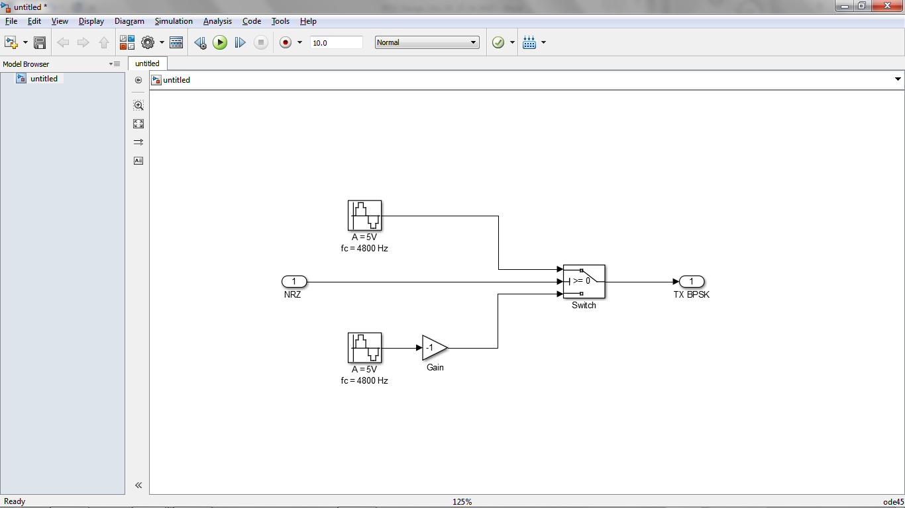

Figure 7. BPSK modulator that uses the Manchester data stream to gate two antipodal sinusoidal carriers that result in the BPSK modulated signal.

Figure 8 illustrates the operation of the BPSK modulator. When a binary ‘1’ is input to the modulator, the positive sine wave is transmitted and when a binary ‘0’ is input, the negative sine wave is transmitted.

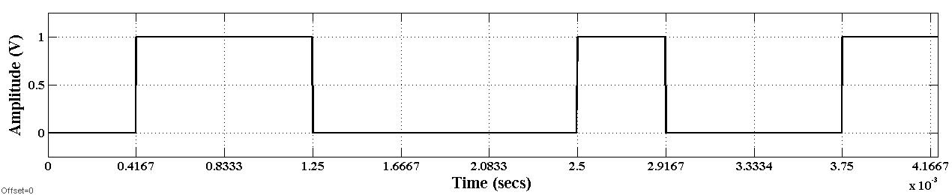

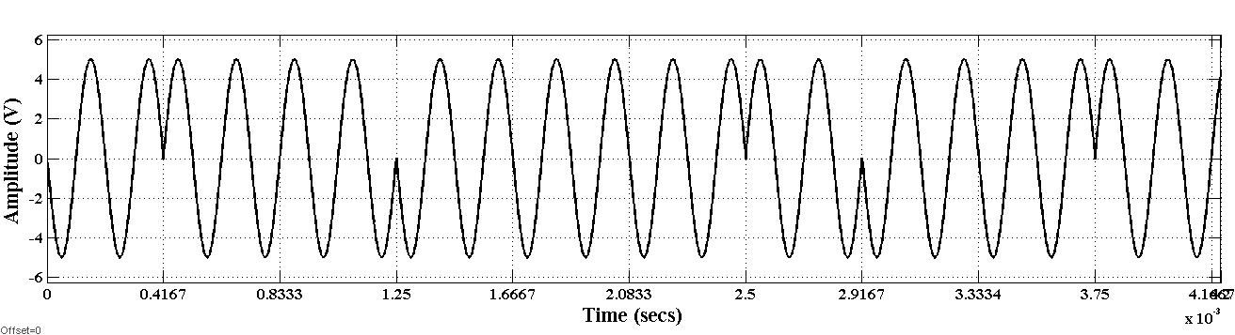

Figure 8. The transmitted BPSK signal has 180 degree phase shifts that correspond to logic level transition of the NRZ data stream.

### 3.1.3 AWGN Channel

The *AWGN Channel* in Simulink was used to model the propagation medium in the software simulation. The Simulink block operates in the *Signal to Noise Ratio (Eb/No)* mode. This mode requires the input signal power of the transmitted BPSK signal. Using the signal information provided in the previous section, we use the following equation to find this input signal power (Silage, 2009):

$$P= \frac{A^{2}}{T_{b}R_{L}}\int_{(i-1)T_{b}}^{iT_{b}}{\sin^{2}\left(k_{p}m_{j}\left(t\right)+θ\right)dt=\frac{A^{2}}{2R_{L}}= \frac{5^{2}}{2}=12.5 W (i-1)T_{b}≤}t≤iT_{b} j=0, 1$$

where the amplitude *A* = 5 V, the bit period *Tb =* 1/2400 s, the load resistance *RL =* 1 $Ω$, the phase shift *kp =* radians, and the phase offset $θ=0$ radians.

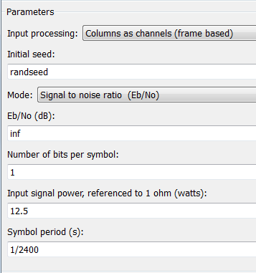

### 3.1.4 FEC-BPSK Demodulator: Carrier, Timing, Data Recovery & Soft-decision Encoding

Coherent demodulation of BPSK requires the receiver to be synchronized with the transmitter. As discussed in Section 1.3, synchronization requires two circuits’ independent circuits. The first is the Costas loop carrier recovery circuit used for suppressed carrier reconstruction and data demodulation and the second is the Early-Late used clock and data recovery. In this section we consider the theory, operation, and design of both circuits.

**Costas Loop Design for Coherent BPSK Demodulation**

The operation of the Costas Loop is explained using simple trigonometry and is illustrated in Figure 9. For simplicity, we assume the received signal is free of noise. This is only to illustrate loop operation.



Figure 9. Time domain model of the Costas Loop carrier recovery and demodulation circuit. It’s operation is described using trigonometric identities.

The received signal, $r(t)$ is the product of the data, $m(t)$ and the modulating carrier with phase, $θ$. This is equivalent to equation (3) where $\left(t\right)∈[1,-1]$.

$r\left(t\right)=m\left(t\right)*A\sin{(2πf_{c}t)}$, $m\left(t\right)∈[1,-1]$ (4)

Referring to Figure 9, the received signal is split between the in-phase and quadrature arms where it is multiplied with the output of the local oscillator with amplitude, $B$ and phase, $φ$. Thus the output of the multiplier in the in-phase arm is:

$$m\left(t\right)A\sin\left(w_{c}t+θ\right)*B\sin{(w_{c}t}+φ)=\frac{m\left(t\right)AB}{2}\left[\cos\left(θ-φ\right)-cos⁡(2w_{c}t+θ+φ)\right] ( SEQ Equation \backslash * ARABIC 5)$$

While the output of the multiplier in the quadrature branch is:

$$m\left(t\right)A\sin\left(w_{c}t+θ\right)*B\cos{(w_{c}t}+φ)=\frac{m\left(t\right)AB}{2}\left[sin\left(2w_{c}t+θ+φ\right)+\sin\left(θ-φ\right)\right] ( SEQ Equation \backslash * ARABIC 6)$$

Note that the VCO in the bottom arm is shifted by ${90 }^{°}$ to produce the quadrature component. Low pass filters (LPF) with cutoff frequencies at $2w_{c}$ remove the double frequency leaving only the cosine and sine of the phase difference.

$$LPF{\left\{\frac{m\left(t\right)AB}{2}\left[\cos\left(θ-φ\right)-cos⁡(2w_{c}t+θ+φ)\right]\right\}}_{2w_{c}}=\frac{m\left(t\right)AB}{2} \cos\left(θ-φ\right) ( SEQ Equation \backslash * ARABIC 7)$$

$$LPF{\left\{\frac{m\left(t\right)AB}{2}\left[sin\left(2w_{c}t+θ+φ\right)+sin⁡(θ-φ)\right]\right\}}_{2w_{c}}=\frac{m\left(t\right)AB}{2} \sin\left(θ-φ\right) ( SEQ Equation \backslash * ARABIC 8)$$

The phase doubler on the right side of the Costas Loop multiplies the output of the in-phase and Quadrature LPF’s. The resulting error signal, $e(t)$, drives the VCO towards phase lock.

$$e\left(t\right)={\left(\frac{m\left(t\right)AB}{2}\right)}^{2}\sin\left[2\left(θ-φ\right)\right] ( SEQ Equation \backslash * ARABIC 9)$$

Assuming the VCO is locked in phase with the carrier of the transmitted BPSK signal ($θ=φ$), then the output of the in-phase LPF from equation (7), reduces to $m\left(t\right)AB/2$ leaving behind only a scaled version of the originally transmitted data. In addition, the error signal $e(t)$ from the phase doubler is reduced to zero implying the receiver is locked in phase with the received signal, $r\left(t\right)$.

However, fundamental questions arise like how long will it take the loop to lock? What is the lock range of the VCO? We can define specifications for the Costas Loop by applying concepts from classical control theory. Small angle approximations make it possible to linearize the Costas Loop in terms of phase. Figure 10 presents the Laplace domain model of the loop where it is assumed that $\sin\left(θ-φ\right)≈θ-φ$.

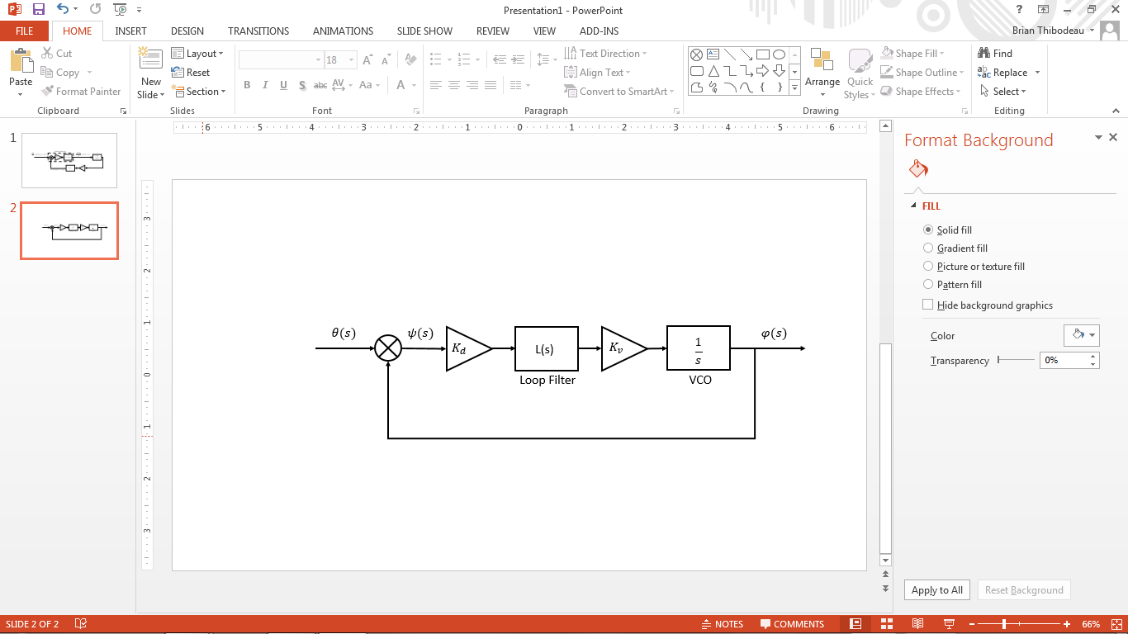

Figure 10. Linearized Costas Loop in the Laplace domain. Note that the $2f_{c}$ filter is omitted in the linearized Laplace model because it is assumed that the double frequency component was filtered leaving only the phase error

The open loop gain is modeled by $K_{d}$ which includes the amplitude of the received signal and the gain of the arm filters. $L(s)$ represents the Loop filter (PI filter) that adjust the error in order to increase or decrease the time to lock. The VCO is modeled by an integrator that accumulates the phase and $K_{v}$ is the VCO gain. The closed loop transfer function of the Costas Loop in Figure 10 is thus given by,

$$H\left(s\right)=\frac{θ(s)}{φ(s)}=\frac{K_{d}K_{v}L\left(s\right)}{s+K_{d}K_{v}L\left(s\right)} , ( SEQ Equation \backslash * ARABIC 10)$$

And the steady error transfer function is,

$$φ\left(s\right)=\frac{sθ\left(s\right)}{s+K_{d}K_{v}L\left(s\right)} . ( SEQ Equation \backslash * ARABIC 11)$$

In order for the PLL to be capable of tracking a phase and frequency step, the appropriate loop filter *L*(s)must be chosen such that steady error transfer has zero error for step ($θ\left(s\right)=1/s$) and ramp ($φ\left(s\right)=1/s^{2}$) inputs. This is accomplished by application of the final value theorem to equation (15).

$$Step Input: φ\left(∞\right)=\lim_{s→0}{ \frac{s^{2}\left(\frac{1}{s}\right)}{s+K_{d}K_{v}L(s)}= 0 } ( SEQ Equation \backslash * ARABIC 12)$$

$$Ramp Input: φ\left(∞\right)=\lim_{s→0}{ \frac{s^{2}\left(\frac{1}{s^{2}}\right)}{s+K_{d}K_{v}L\left(s\right)}}{= \frac{1}{K_{d}K_{v}L\left(s\right)} }( SEQ Equation \backslash * ARABIC 13)$$

The results of the final value theorem tell us that the loop filter must contain an integrator so that the error at infinity goes to zero. Two common loop filters that accomplish this are the lead-lag filter and the proportional integral filter (PI). In this design, the PI filter was chosen which takes the form,

$$L\left(s\right)=K_{P}+\frac{K_{I}}{s} ( SEQ Equation \backslash * ARABIC 14)$$

Where $K_{P}$ is the proportional gain and $K_{I}$ is the integral gain. After substituting the expression for the loop filter into the closed loop transfer function given by equation (18), the new closed transfer function describing the Costas Loop’s behavior is,

$$H\left(s\right)=\frac{K_{d}K_{v}K_{P}s+K_{d}K_{v}K_{I}}{{s^{2}+K_{d}K_{v}K_{P}s+K}_{d}K_{v}K_{I}} . ( SEQ Equation \backslash * ARABIC 15)$$

Recognizing that equation (19) is a prototypical second order transfer function, the PLL transfer function can be re-written in terms of the natural frequency $w_{n}$ and the dampening ratio $ξ$ (Crawford, 2008).

$$H\left(s\right)=\frac{w_{n}\left(1+\frac{2ξ}{w_{n}}s\right)}{s^{2}+2ξw_{n}+w_{n}^{2}} ( SEQ Equation \backslash * ARABIC 16)$$

Where,

$$w_{n}=\sqrt{K_{d}K_{v}K_{I}} (20.1)$$

$$ξ=\frac{K_{d}K_{v}K_{P}}{2w_{n}} (20.2)$$

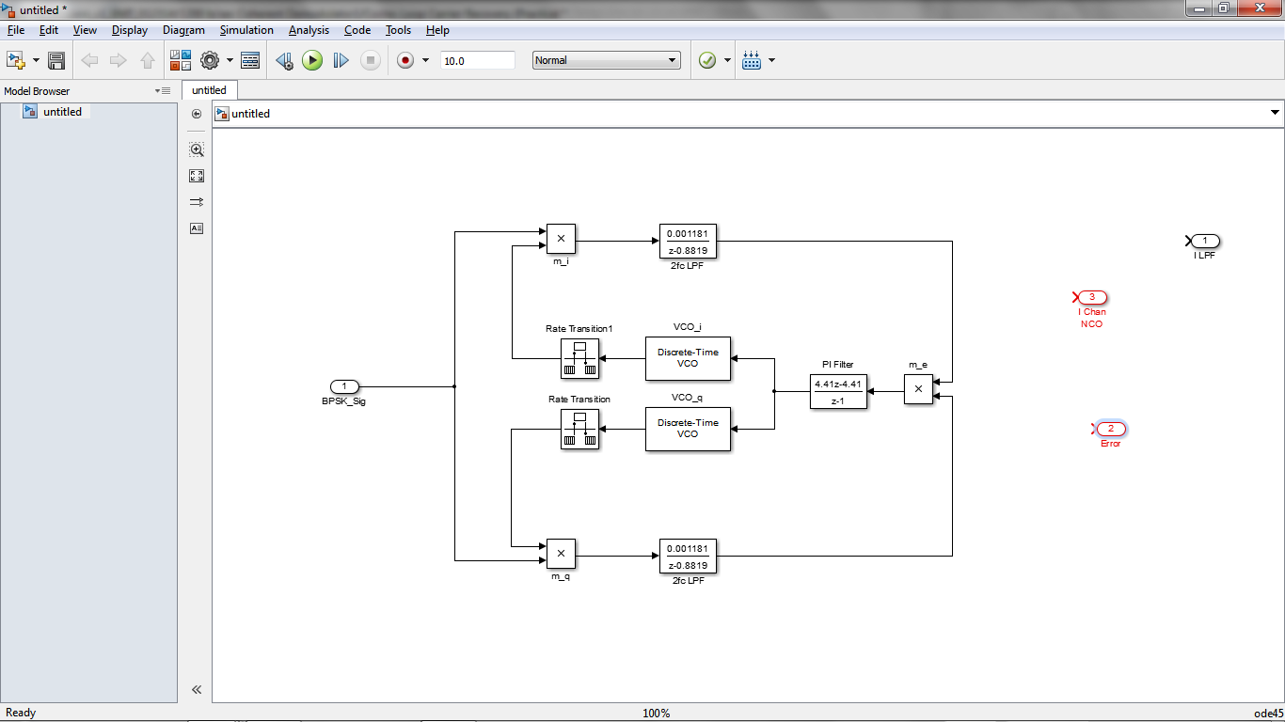

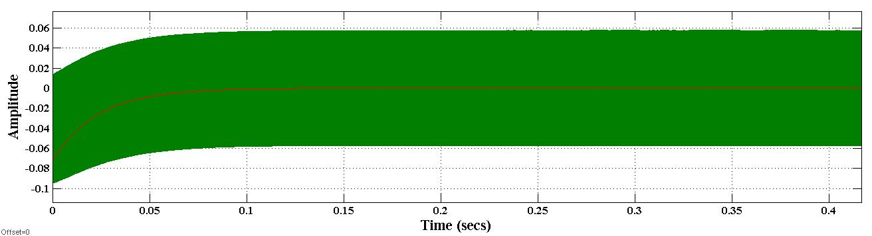

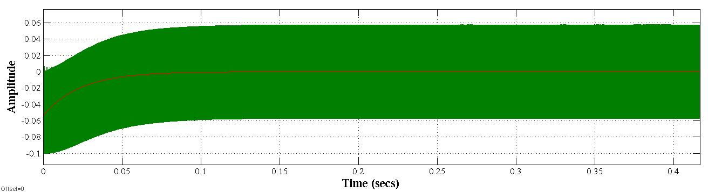

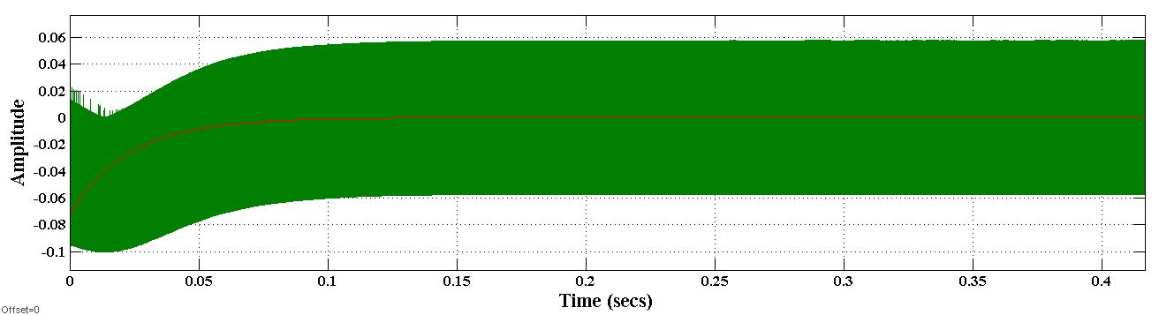

**Timing Recovery Using Early-Late Gate Synchronizer**

The synchronization between the transmitter and the receiver is done using the Early-Late Gate Timing Recovery circuit, among the several other circuitry available, the Early Late Gate has proven to be the ideal design in communication links. The Early-Late Gate provides the opportunity to constantly ameliorate synchronization through its feedback components and its loop filter. As section 1.3.4 explains, the error between the early clock and the late clock is to converge to zero in ideal conditions. For the error to converge to zero at a certain time $t_{s}$, the Early Late Gate depends on its loop filter component in circuitry. This component is used to minimize the settling time of the circuit to synchronize the received signal. Therefore, based on those facts, it was found beneficial to implement a PID controller for achieving an appropriate settling time. Figure 6, would then consist of a PID controller for its loop filter, while the remaining components will remain the same.

On purpose of obtaining a zero error rate from the Early Late Gate, the early and late clocks must operate within a certain region which will allow the integrators to integrate an equal amount of energy from the two branches. This region is commonly referred to as the *correct receiver timing* while the *early/ late* *receiver timing* are known to detriment the error between the early and late gates. Figure 15 illustrates the desired condition for the three samples to operate in, note that the area integrated by the integrators will be identical. Before it locks itself into the *correct timing* the circuit first adjusts its clock using the PID controller. The controller, makes use of the Proportional and Integral gains to drive the output clock from the error signals. The gains PI controller can be found in table 3.

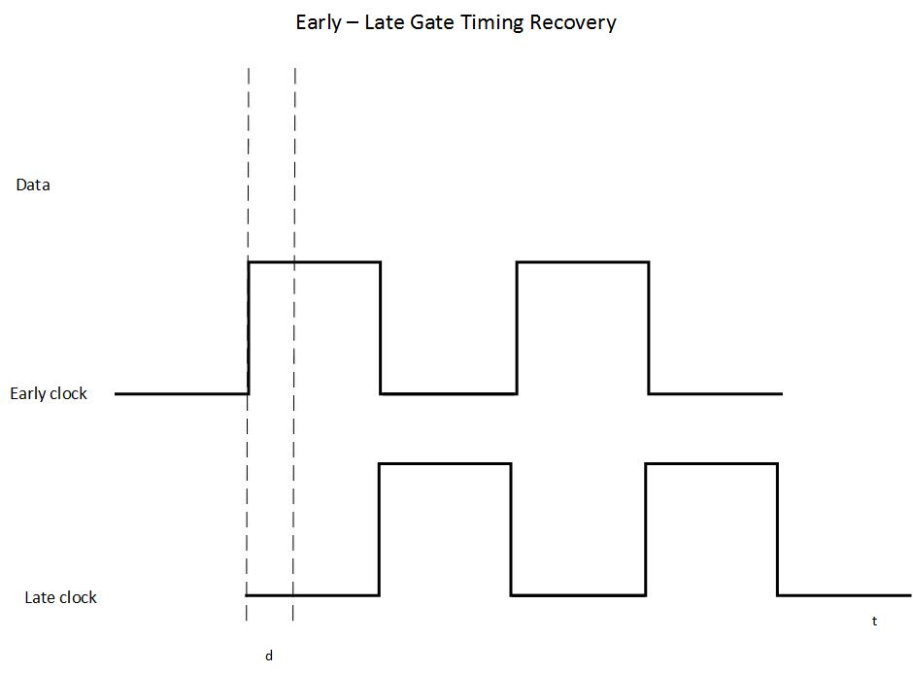

Figure 15. Ideal timing between the Early and Late branch

|  |  |
| --- | --- |
| P | I |
| 0.15 | 0.25 |

Table 3. Proportional and integral values for the Early-Late Gate’s PID controller

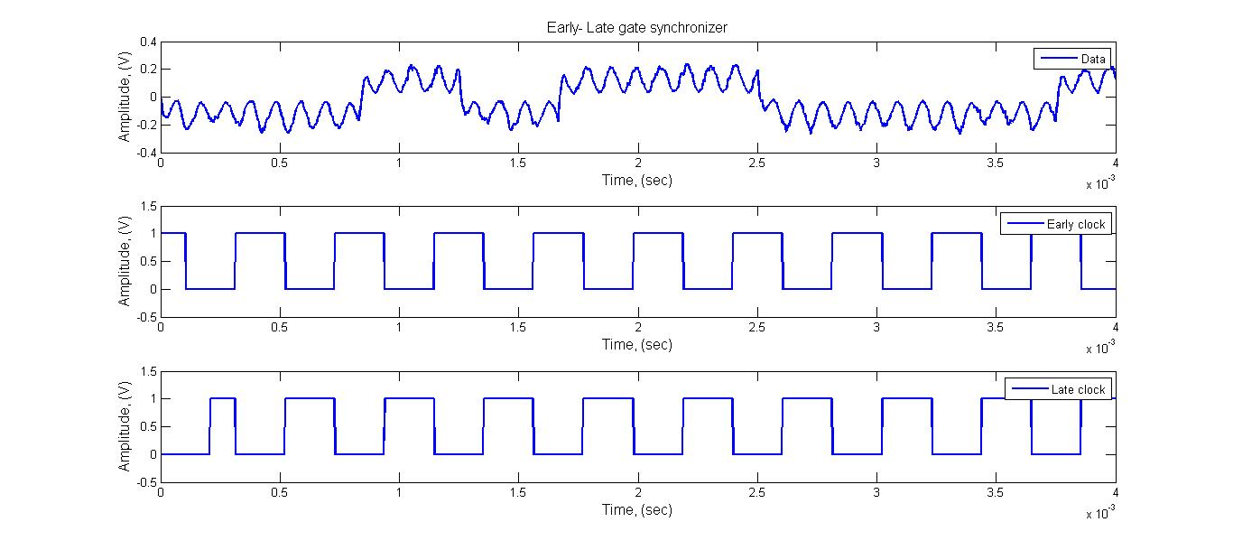

Figure 16. Early Late Gate operating within correct receiver timing

Figure # depicts the Early-Late Gate’s implementation in Matlab Simulink, since the signal is sampled at a rate of 480E+3, the demodulated signal will be composed of 200 samples hence, a delay of 100 samples on the clock (at the late gate) is equivalent to a half-bit delay and is then used to control the *integrator* and the *sample and hold blocks* of the late branch. And finally, the Voltage Controlled Clock (VCC) is implemented with a traditional VCO that is later converted into a square wave using a bang-bang controller.

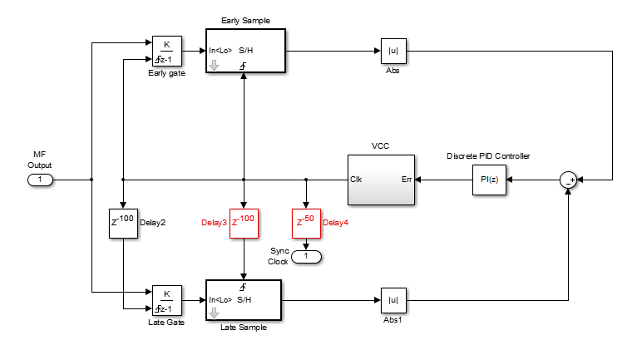

Figure 17. Simulink implementation of the Early- Late gate timing synchronizer

Within the *correct timing region,* the error between the late and early branch is expected to be zero as Figure 16 illustrates, both branch will integrate different region of the waveform, but eventually, the amount of energy will sum to the same quantity. The error is then obtained by the subtraction of the two signals, the error is kept small by the use of the PID controller which drives the clock to lock unto the edges of the signal. Figure 18 shows the error rate of the Early- Late Gate circuit, by first observation, it can be seen that the energy at the two signals are the same except for very small instances where one branch peaks more than the other. By tuning the PID controller, those instances are weighted accordingly to drive to the VCC providing the synchronized clock.

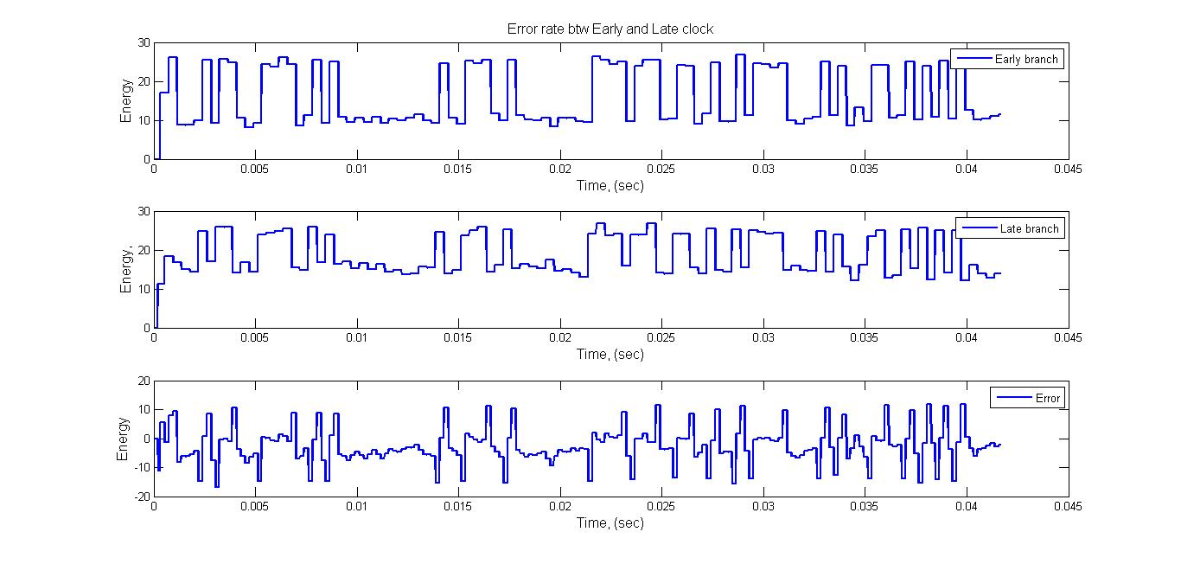

Figure 18: Error rate between the Late and Early branch

**Soft-decision Encoding**

Instead of implementing hard-decision decoding and producing a logic 0 or 1 as output, the output of the matched filter is scalar quantization (SQ) encoded into a 3-bit signal. The range of the 3-bit output of the SQ encoder represents the confidence level of the demodulated signal actually being a logic 0 or 1 (shown in Table 4). This indecisiveness justifies the term “soft-decision” decoding. Figure 42 shows the circuit used to implement this 3-bit scalar quantization encoding.

|  |  |
| --- | --- |
| **Input Value** | **Confidence** |
| 0 | Most confident zero |
| 1 | Second most confident zero |
| 2 | Second least confident zero |
| 3 | Least confident zero |
| 4 | Least confident one |
| 5 | Second least confident one |
| 6 | Second most confident one |
| 7 | Most confident one |

Table 4. This table shows the output of the *Scalar Quantization Encoder* which is used by the *Viterbi Decoder.*

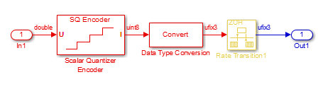

Figure 42. Scalar Quantization Encoder scalar quantizes BPSK demodulator output into a 3-bit value. This 3-bit “soft-decision” output is used by the *Viterbi Decoder.*

### 3.1.5 Forward Error Correction: Soft-decision Viterbi Decoding

There is a 6-bit buffer at the output of the soft-decision BPSK demodulator. The purpose of the buffer is to collect two of the 3-bit data and input it into the Viterbi decoder. Recalling that the code rate of this convolutional code is 1/2, the buffer essentially undoes what the 2-bit serializer did at the transmitter.

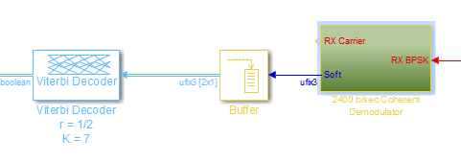

The soft-decision Viterbi decoder uses Hamming distance and maximum likelihood to decode the convolutional encoding. The ½ code rate convolutional code with constraint length 7 has a *free distance* *df* of 10 (Sklar, 2001). Essentially, free distance is the minimum Hamming distance between the all-zero path and any arbitrary path that diverges and remerges with the all-zero path (Sklar, 2001). It is essentially a measure of how well a convolutional code corrects errors. The higher the free distance, the better the convolutional code is at correcting random errors. A Viterbi decoder can correct up to *t* random errors (Sklar, 2001):

$$t= \left\lfloor \frac{d_{f}-1}{2}\right\rfloor$$

Hence, the ½ code rate convolutional code with constraint length 7 can correct up to 4 random errors in a received signal. The upper-bounded probability of bit error for the (2, 1, 7) convolutional code with BPSK and soft-decision decoding (Sklar writes ‘hard-decision decoding’; Brandon claims this is incorrect) is expressed as follows:

$$P_{b}≤ \frac{Q\left(\sqrt{\frac{7E_{b}}{N_{0}}}\right)}{{\left[1-2e^{\left(\frac{-E_{b}}{2N_{0}}\right)}\right]}^{2}}$$

This upper-bounded probability of bit error is related to an upper-bounded coding gain (dB) expressed as follows (Sklar, 2001):

$$coding gain ≤10 \log_{10}\left(rd_{f}\right)≅7 dB$$

where the code rate *r* is:

$$r= \frac{k}{n}= \frac{1}{2}$$

The result of the coding gain inequality means that BPSK with soft-decision Viterbi decoding (‘2,1,7’ code, ½ code rate, constraint length 7) offers at most 7 dB of coding gain compared to un-coded BPSK.

The *Viterbi Decoder* uses a *traceback length* of 48, which is within the recommended range for a convolutional code with constraint length *K* = 7 (Sklar, 2001). The traceback length is a metric for path memory since the convolutional code depends on both currently inputted data and recently inputted data.

### 3.1.6 Simulation Results

One of the main goals of this senior design project is to implement BPSK modulation with soft-decision Viterbi decoding via both computer simulation (Simulink) and hardware implementation (FPGA). From the computer simulation models, we are able to determine if the observed BER performance results correlate with theory. If the results do compare with theory, the next goal would be to implement the models in FPGA hardware. The overall objective would be to assess the power consumption savings when using BPSK modulation with soft-decision Viterbi decoding versus just BFSK (Bell 202) modulation or BPSK modulation.

The following graph (Figure 43) shows the BER performances for several targeted amateur satellite telemetry communication schemes. The graph shows that there is approximately a 3 dB improvement to the perceived SNR when using BPSK instead of BFSK. The results of simulation for BPSK with soft-decision Viterbi decoding provides a maximum of 7 dB coding gain when compared to un-coded BPSK. This result matches with the theoretical coding gain inequality provided in the previous section. Additionally, there is approximately 2 dB of coding gain when using soft-decision Viterbi decoding instead of hard-decision Viterbi decoding (Viswanathan, 2013). The curve for BPSK with hard-decision Viterbi decoding satisfies this fact by consistently performing 2 dB worse than soft-decision Viterbi decoding.

These BER performance results serve as the basis for determining how much power consumption is reduced by opting to use BPSK with soft-decision Viterbi decoding instead of just BFSK (Bell 202) or BPSK in amateur radio satellite telemetry communications. Namely, these results provide a basis for a *budget link analysis*, which is a procedure used to assess the overall power budget of a digital communication system. Obviously, in our case the digital communication system is an amateur satellite communications over AWGN.

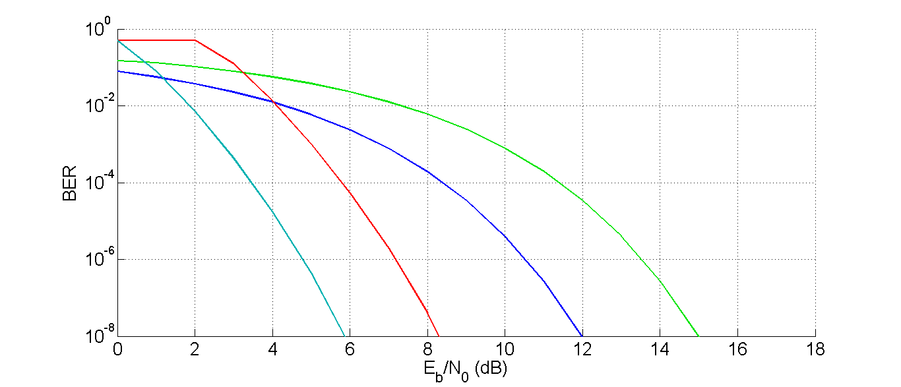

Figure 43. BER performance for several amateur satellite telemetry communications schemes over AWGN. The green curve is the BER performance for coherent BFSK. The dark blue curve is the BER performance for BPSK. The red curve is the upper-bounded BER performance for hard-decision BPSK with the (2, 1, 7) convolutional code. The teal curve is the upper-bounded BER performance for soft-decision BPSK with the (2, 1, 7) convolutional code.

## Hardware Implementation using ISE Project Navigator

This section discusses the hardware implementation of the software model (ModelSim) showcased in the previous section, *3.1 Software Simulation Using Matlab/Simulink*. The goal is to conserve all of the results of the software model during hardware implementation. With a sufficiently developed software model, it should be relatively effortless to realize the software model in hardware. Hence, this section will showcase the hardware architecture of this senior design project and the alterations that were needed to realize the software model in hardware. For a comparison of the results of the software model and hardware implementation, please see the next section, *4 Evaluation*.

The hardware implementation of this senior design project includes using a desktop PC as a bit error tester (BERT) and an FPGA as the design under test (DUT). The role of the BERT is to transmit 10,000 bits of data to the DUT, wait for the DUT to process the data, and then receive 10,000 bits to begin the BER calculation. The RS-232 serial communications scheme is used to interface the BERT to the DUT. The RS-232 parameters include 1200 b/sec bit rate, 8 data bits, no parity bit, one stop bit, and no hardware or software flow control. The role of the DUT is to implement the two 10,000 bit storage buffers and the digital communication loopback. One storage buffer collects 10,000 bits from the BERT. The other storage buffer collects the 10,000 bits from the digital communication loopback before being returned to the BERT. The digital communication loopback consists of the BPSK modem with forward error correction and the propagation channel model (AWGN). The next figure depicts the high-level system architecture of this senior design project.

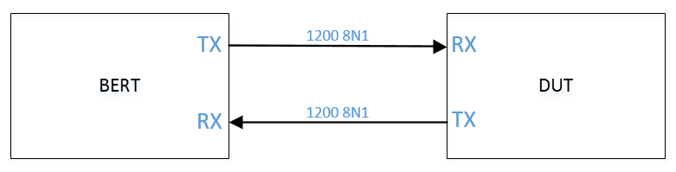

Figure 44. High-level system architecture of this senior design project. A desktop PC is used to implement bit error test (BERT) functionality while an FPGA is used to implement the design under test (DUT). The RS-232 serial communication scheme is used to interface the BERT to the DUT. The chosen RS-232 parameters are 1200 b/sec bit rate, 8 bits of data bits, no parity bit, one stop bit, and no software or hardware flow control.

The primary components of the BERT will be discussed in the next section, *3.2.1* *Serial Terminal Program & Software BER Calculation Script*. The DUT is realized using two products from an electronics company named Trenz Electronics. The two products are the TE0304 Carrier Board and the TE0630 FPGA Module. An example of this setup is shown in the next figure. An FPGA module is sitting atop of the carrier board. The carrier board is equipped with an abundance of I/O. Important to this senior design is the DCE RS-232 port located at the bottom of the next figure.

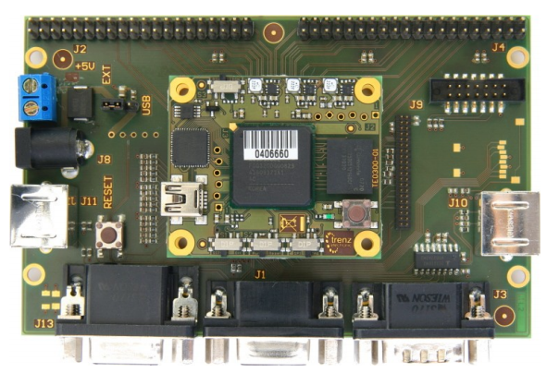

Figure 45. Trenz Electronics products used for hardware implementation of the DUT of this senior design project. The TE0304 carrier board is shown supporting an FPGA module (not the TE0630). The DCE RS-232 port is located at the bottom of the image. The port is used to interface to the BERT.

The next figure shows the actual DUT set up for use. The RS-232 cable is clearly interfaced at the top of the image.

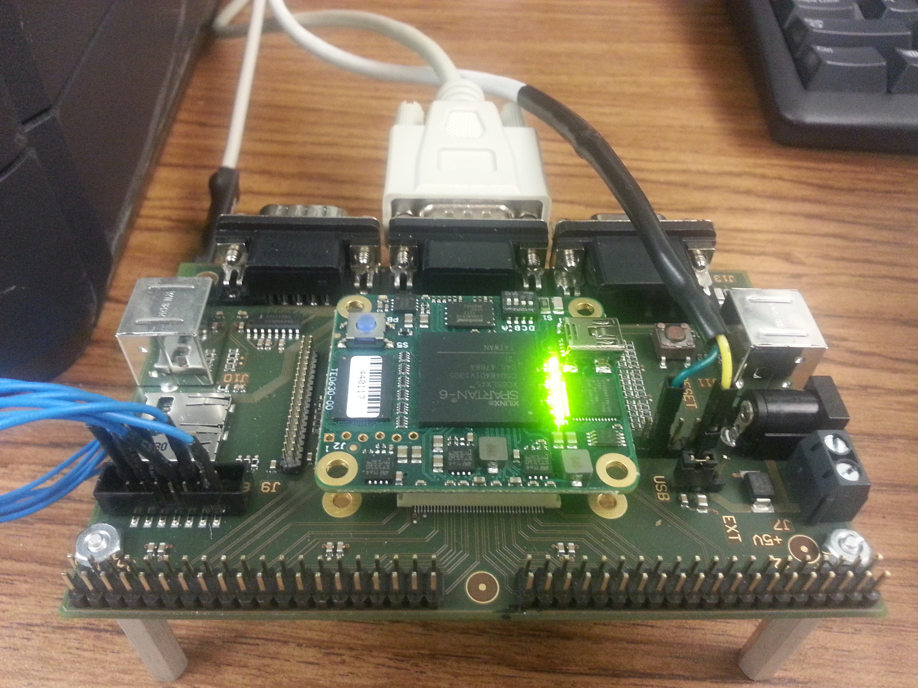

Figure 46. Actual setup of DUT for this senior design project. It is shown interfaced to the BERT (PC; left) via RS-232 serial communication.

The DCE port on the TE0304 carrier board connects to the FPGA module via two board-to-board (B2B) connectors. The next figure shows the high-level system architecture of the DUT as implemented on the FPGA module. The left side of the figure represents inputs, while the right side represents outputs.

Figure 48 depicts the top-level I/O wrapper module (top I/O module) of the DUT. The FPGA pins shown in Figure 47 are clearly shown as the inputs and outputs to the top I/O module. The top I/O module consists of several sub-modules. Two of the sub-modules (rcvr.v, txmit.v) interface with the BERT via the RS-232 serial communication scheme. The sub-module satcom.v encapsulates the entire digital communication loopback consisting of the two 10,000 bit storage buffers, the BPSK modem with forward error correction, and the propagation channel model (AWGN). There are two sub-modules dedicated to DAC interfacing (for testing purposes). Please see the associated Verilog design files for more details about these sub-modules.

The remainder of this section (3.2) will delve deeper into the hardware implementation of the BERT and DUT. We begin by discussing the primary components of the BERT in the next section, *3.2.1 Serial Terminal Program & Software BER Calculation Script*.

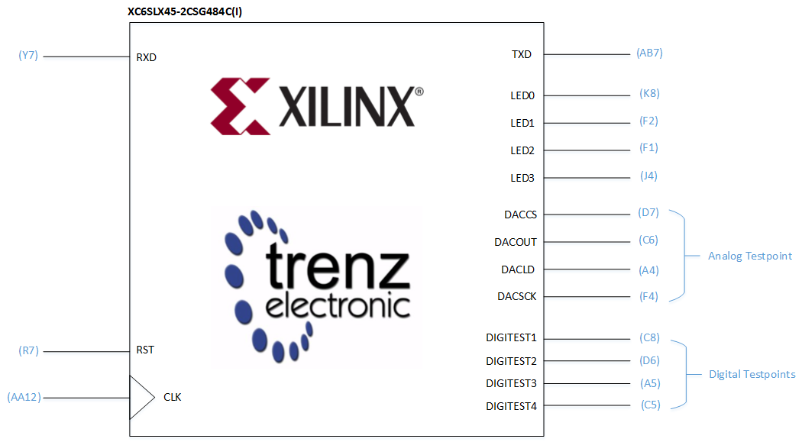

Figure 47. High-level system architecture of the DUT of this senior design project. Shown is a functional block diagram of the Xilinx Spartan 6 XC6SLX45-2CSG484C(I) located on the TE0630 FPGA module. The FPGA pins used are highlighted and associated with the internal functionalities. Namely, there are pins used to interface to the DCE RS-232 port of the TE0304 carrier board, 100 MHz system clock, system reset, user LEDs, and PModTM ports. The PMod ports are used to interface with a DAC or logic analyzer for testing purposes.

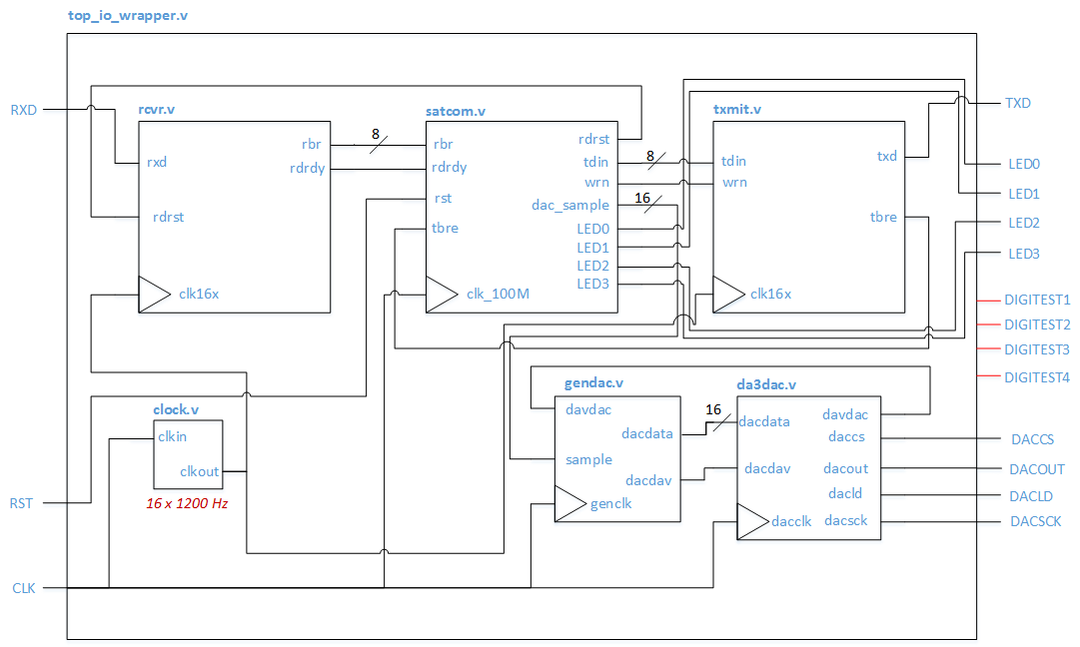

Figure 48. The top-level I/O wrapper module for the DUT. This module interfaces to the various I/O available to the FPGA including RS-232 ports, 100 MHz system clock, system reset, four user LEDs, and two PModTM ports for interfacing to a DAC or logic analyzer. The sub-modules implement RS-232 interfacing (rcvr.v, txmit.v), digital communication loopback (satcom.v), and DAC interfacing (gendac.v, da3dac.v). The four digital testpoint signals (DIGITEST1, etc.) are reserved for testing/investigating any digital signal throughout the entire DUT. Access to ChipScope Pro software logic analyzer or Hardware-In-The-Loop software would have eliminated the need for the DAC and PModTM interfacing.

### 3.2.1 Serial Terminal Program & Software BER Calculation Script

A serial terminal program was used to interface the BERT (PC) to the DUT (FPGA) via the RS-232 serial communication scheme. The RS-232 parameters used were 1200 b/sec bit rate, 8 data bits, no parity bit, one stop bit, and no software or hardware flow control. The purpose of the BERT is to provide the DUT 10,000 bits for processing and then subsequently store the 10,000 bits returned from the DUT. The serial terminal program is used to perform this feat. Specifically, the Tera Term Web 3.1 serial terminal program was used in this senior design project. The software was setup to implement the RS-232 scheme mentioned above as follows (Figure 48).

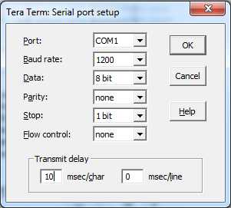

Figure 48: RS-232 serial terminal setup parameters for

1200 8N1 communication between BERT and DUT. A

10 millisecond delay is used between each ASCII character

transmission since no flow control is used.

The next image shows a transmit delay between each ASCII character transmitted from the BERT to the DUT. The size of the transmit delay is a function of how long it takes the DUT to receive (then store) and transmit (then re-transmit) an ASCII character without flow control.

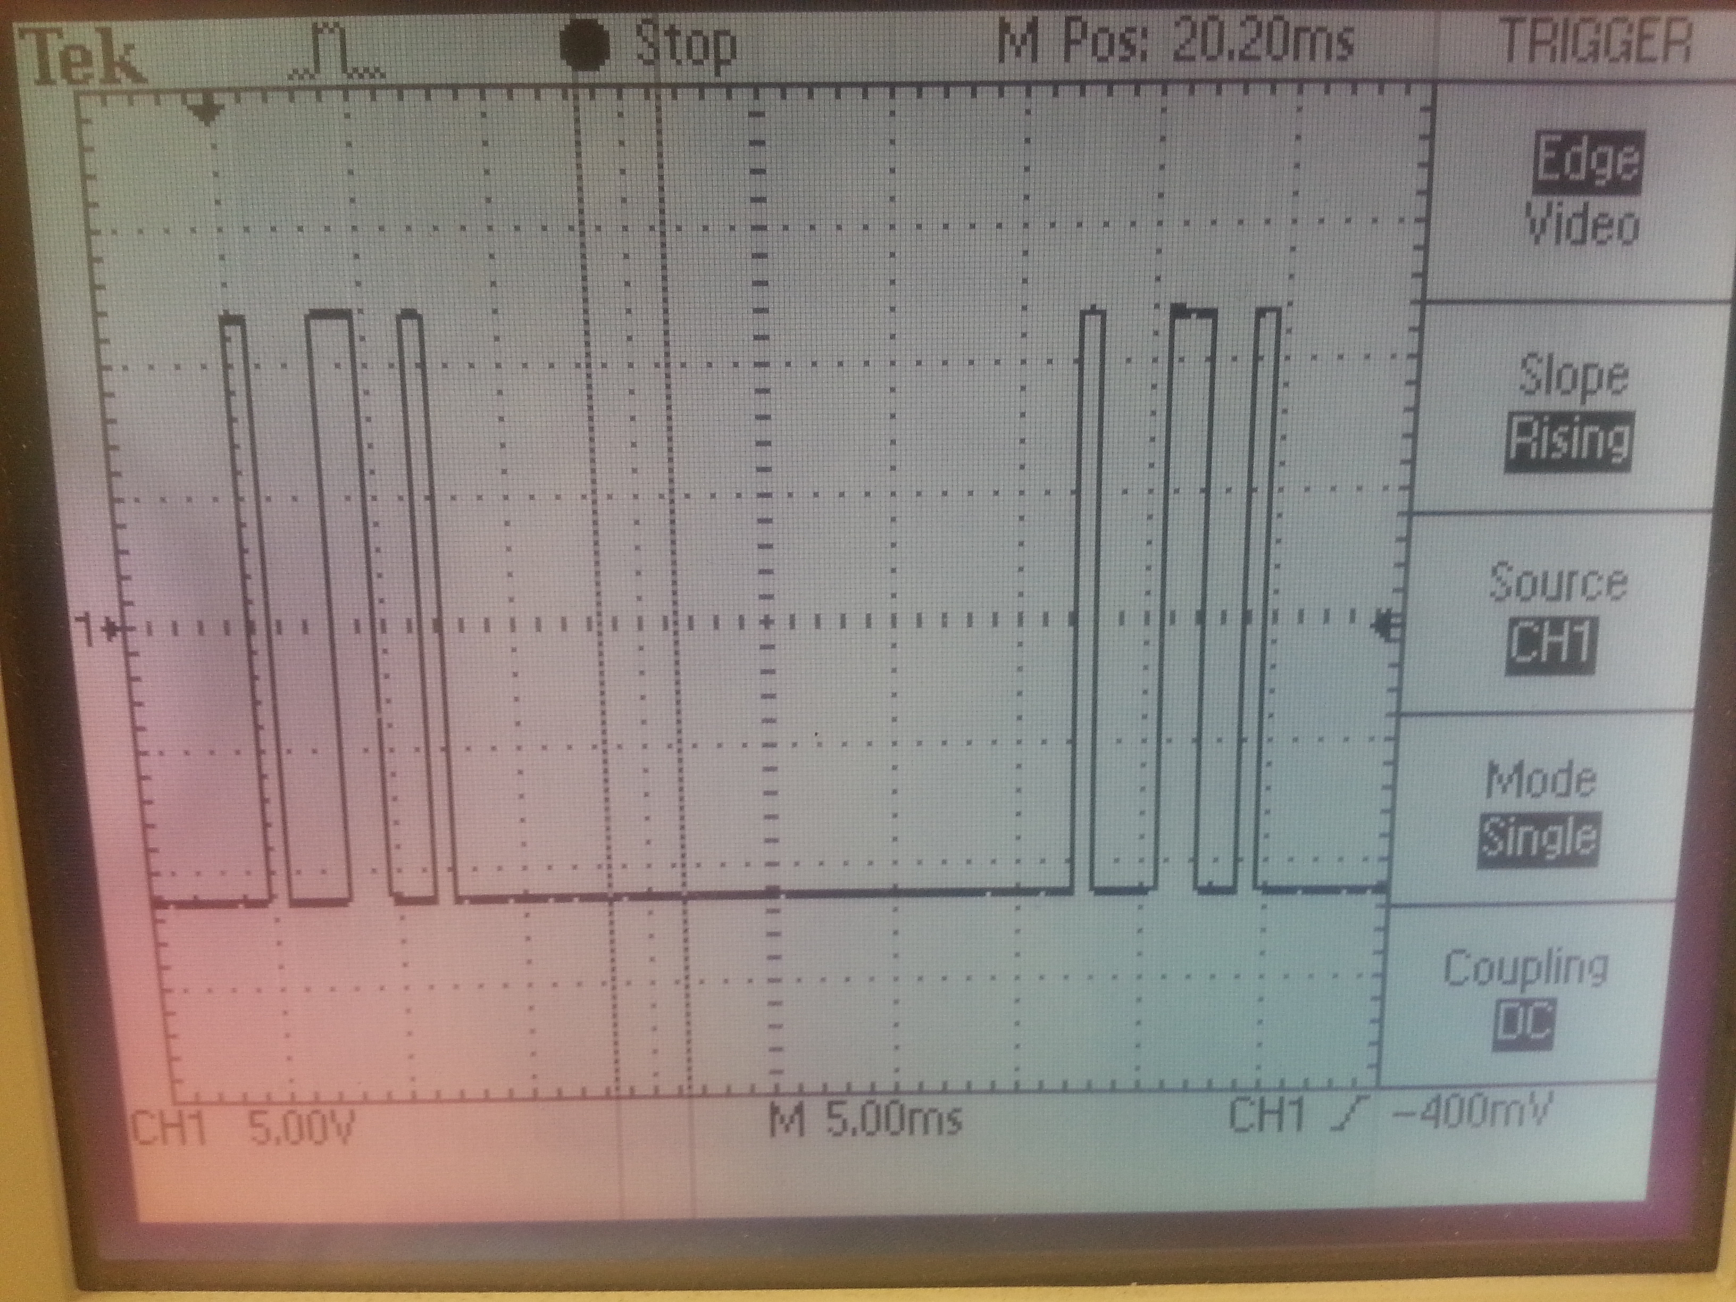

Figure 49. Two ASCII characters being transmitted from the BERT to the DUT using

1200 8N1 RS-232 communication. A 25 ms transmit delay occurs between each ASCII

character transmission, but the delay can be reduced. How much of a reduction depends

on how quickly the DUT can receive or transmit a single ASCII character.

The Tera Term software can send a file of data. This feature was used to transmit a 10,000 bit file to the DUT. An ASCII character is 8 bits in size. 1250 ASCII characters are 10,000 bits in size. Hence, 1250 ASCII characters comprise the sent file. Further, this means that it takes approximately 23 seconds to transmit the 10 kb file to the DUT:

$$\left(1250 ×10 ms\right)+ 1250×\left(\frac{1+8+1}{1200} s\right)≅23 seconds$$

It takes 23 seconds also to receive the 10 kb of data from the DUT. Hence, it takes approximately 46 seconds to fully transmit and receive the 10 kb file. Keep in mind, this 46 seconds does NOT include the time required to propagate the 10 kb file through the digital communication loopback of the DUT. This processing time will be further investigated in the upcoming sections.

**TODO: Description of the software BER calculation script**

### 3.2.2 10K-bit Receive and Transit Storage Buffers

As shown in Figure 49, RS-232 serial communication is an asynchronous communication method. Even though our scheme may use 1200 b/sec bit rate, the actual data rate is not 1200 b/sec. Depending on the size of the transmit delay between ASCII character transmission, the data rate can be much lower than the RS-232 bit rate. Hence, it is necessary for the DUT to store the received data bits in a buffer until all 10,000 bits are received by the BERT. Once the 10,000 bits are stored, then a continuous data stream (1200 b/sec) can flow into the digital communication loopback. This is the description of the 10K-bit receive storage buffer. A transmit buffer has similar functionality. Its role is to collect the 10,000 bits that entered the digital communication loopback. Once the 10,000 bits are stored, the bits are then asynchronously transmitted back to the BERT for the BER calculation.

Figure 48 shows the RS-232 receiver module (rcvr.v) of the DUT which interfaces to the RS-232 transmitter of the BERT. The receiver module (rcvr.v) processes the incoming RS-232 signal from the BERT, resulting in an 8-bit ASCII character. This 8-bit character is then provided to satcom.v for storage in a 10,000 bit buffer. The role of this 10K-bit buffer is to *asynchronously* store 10,000 bits of data (1250 ASCII characters) from the BERT before releasing the stored bits into the digital communication loopback at a continuous data rate of 1200 b/sec. Once the 10K-bit buffer is full, it will not store any new data until all 10,000 bits are transmitted into the digital communication loopback.

Further, the 10K-bit transmit buffer must know when to begin storing bits from the digital communication loopback. That is, when the 10K-bit receive buffer begins to pass bits into the digital communication loopback, the 10K-bit transmit buffer must know how long of a period to wait before the bits propagate to its input port. Consequently, a transmit delay feature is implemented by the 10K-bit transmit. This feature works as follows:

1. the 10K-bit receive buffer fills up with 10,000 bits
2. the 10K-bit receive buffer alerts the 10K-bit transmit buffer to this event
3. the 10K-bit receive buffer begins passing the 10,000 stored bits into the digital communication loopback
4. the 10K-bit transmit buffer waits a precise amount of time after receiving the alert
5. the 10K-bit transmit buffer fills up with 10,000 bits

A controller module (buffercontrol.v) is used to implement the handshake signaling interface between the RS-232 receive and transmit modules (rcvr.v, txmit.v) and the 10K-bit receive and transmit storage buffer modules (rcvbuffer.v, txmitbuffer.v). The next figure depicts how this all fits together.

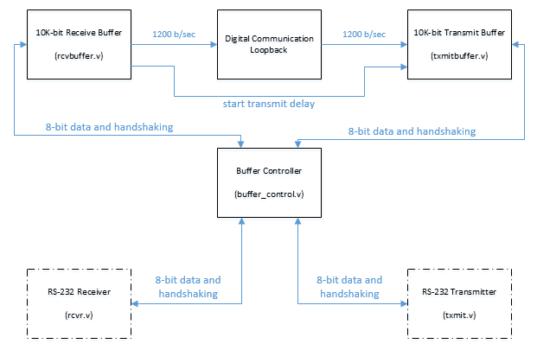

Figure 50. A high-level block diagram depicting the interfacing between the RS-232 receiver and transmitter modules (rcvr.v, txmit.v) and the 10K-bit receive and transmit storage buffers (rcvbuffer.v, txmitbuffer.v). The 8-bit character received by the RS-232 receiver module (rcvr.v) is passed to the buffer controller module (buffer_control.v). The character is then passed from the buffer controller module to the 10K-bit receive storage buffer. Once 1250 characters (10,000 bits) are stored in the 10K-bit receive buffer, the 10K-bitt transmit buffer is alerted and starts a transmit delay timer. Once the transmit delay time passes and the 10K-bit transmit storage buffer stores 10,000 bits, it passes the bits as 8-bit characters to the buffer controller module. From there, the buffer controller passes the 8-bit character to the RS-232 transmitter module (txmit.v).

The next figure (Figure 51) is a human-readable flow chart of the state machine within the buffer controller module (buffer_control.v). The state machine consists of eleven states. Six states (colored blue) control the interface between the RS-232 receiver module (rcvr.v) and the 10K-bit receive storage buffer module (rcvbuffer.v), one state (colored green) indicates that 10,000 bits are passing through the digital communication loopback, and four states (colored red) control the interface between the 10K-bit transmit storage buffer module (txmitbuffer.v) and the RS-232 transmitter module (txmit.v). Three of the user LEDs on the FPGA module are used to identify which of the three group of states the DUT is currently in. LED0 is associated with the six states, LED1 is associated with the one state, and LED2 is associated with the four states. A fourth user LED (LED3) is used to indicate whenever the RS-232 transmit or receive modules (txmit.v, rcvr.v) are actively processing data.

**State 0** of the state machine (Figure 51) is entered upon the start of running FPGA image or upon system reset. This state is used to reset the RS-232 receiver module and enable it to detect a new RS-232 packet. This state is entered whenever a new RS-232 packet is needed by the 10K-bit receive storage buffer module. This state activates LED0 to indicate that the RS-232 receiver module is working with the 10K-bit receive storage buffer to store 10,000 bits of data from the BERT. **State 1** is used to un-reset the RS-232 receiver module. **State 2** is used to wait for a new RS-232 packet. If a new packet is asynchronously detected, state 3 is entered, otherwise the state machine remains in state 2. **State 3** passes the received packet to the 10K-bit receive storage buffer module. State 3 is then used to determine when the 10K-bit receive storage buffer module is done storing the received packet. If the packet is not yet stored, the state machine stays in state 3. If the packet is stored and the 10K-bit buffer is not full, the state machine enters state 4. If the 10K-bit buffer is full, the state machine enters state 5. **State 4** is used to implement handshake signaling between the RS-232 receiver module and the 10K-bit receive storage buffer module. When the handshake is completed, the state machine enters state 0. **State 5** is used to dispense the 10K-bit receive buffer when it becomes full. When the 10K-bit receive buffer is emptied, an alert signal is sent from the 10K-bit receive buffer module to the 10K-bit transmit buffer module. This signal is a part of the transmit delay functionality of the 10K-bit transmit buffer module. When the 10K-bit receive buffer is emptied, the state machine enters state 6.

**State 6** is used to indicate that the 10,000 received bits are being passed through the digital communication loopback. This state deactivates LED0 and activates LED1 to indicate that the 10K-bit transmit buffer module has not yet received 10,000 bits. Once the 10K-bit transmit buffer module receives 10,000 bits, the state machine enters state 7.

**State 7** is used to indicate whether the RS-232 transmitter module is busy transmitting an ASCII character or not. If the former is true, the state machine enters state 8, otherwise the state machine remains in state 7. **State 8** is used to pass a stored character (8 bits) from the 10K-bit transmit buffer to the RS-232 transmitter module. If the 10K-bit transmit buffer is empty, the state machine enters state 0. If 8 bits of data is still being prepared bit the 10K-bit transmit buffer, the state machine remains in state 8. If 8 bits of data is available for the RS-232 transmitter module, the state machine enters state 9. **State 9** is used to implement the handshake signaling between the buffer controller module and the 10K-bit transmit buffer module. Once a successful handshake occurs, the state machine enters state 10. **State 10** is used to implement the handshake signaling between the buffer controller module and the RS-232 transmitter module. Once a

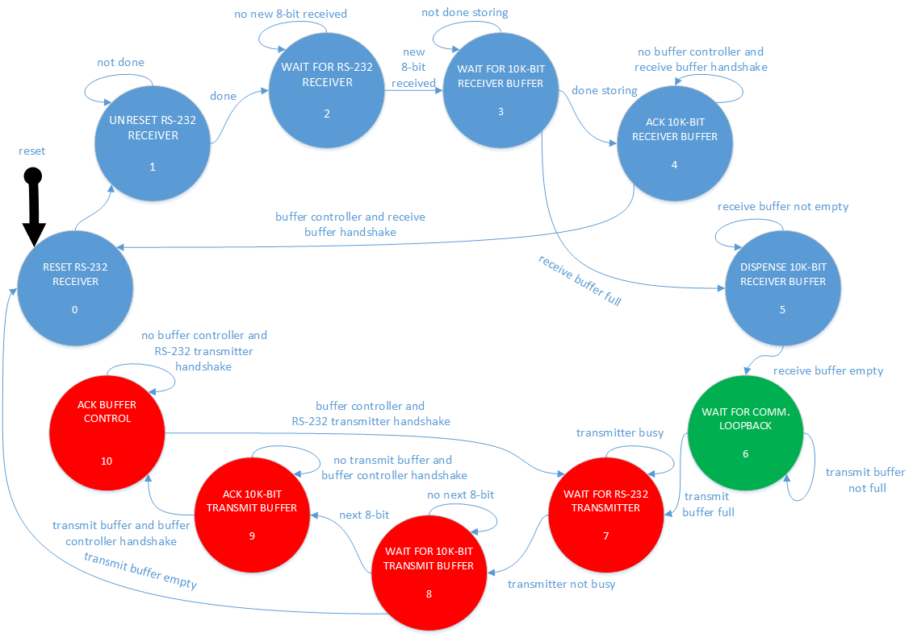

Figure 51. Human-readable flowchart of the state machine in the buffer controller module (buffer_control.v). The state machine consists of eleven states. Six states (colored blue) control the interface between the RS-232 receiver module (rcvr.v) and the 10K-bit receive storage buffer module (rcvbuffer.v), one state (colored green) indicates that 10,000 bits are passing through the digital communication loopback, and four states (colored red) control the interface between the 10K-bit transmit storage buffer module (txmitbuffer.v) and the RS-232 transmitter module (txmit.v).

successful handshake occurs, the state machine enters state 7.

In the Appendix, you will find the Verilog design files discussed in this section described in the utmost detail.

### 3.2.3 Forward Error Correction: Convolutional Encoder & 2-bit Serializer

### 3.2.4 FEC-BPSK Modulator

### 3.2.5 AWGN Channel

### 3.2.6 FEC-BPSK Demodulator: Carrier, Timing, Data Recovery & Soft-decision Encoding

### 3.2.7 Forward Error Correction: Soft-decision Viterbi Decoding

# EVALUATION (Brandon)

# SUMMARY AND FUTURE WORK

# ACKNOWLEDGEMENTS

# REFERENCES

Alminde, L., Bisgaard, M., Vinther, D., Viscor, T., & Ostergaard, K. Z. (2002). *Robustness of radio link between AAU-cubesat and ground station.*Unpublished manuscript.

Capitaine, T., Barrandon, L., Bourny, V., Senlis, J., Le Mortellec, A., Astier, R., et al. (2010). Robust satellite AX25 frames demodulation. Paper presented at the *The Small Satellites Systems and Services (4S) Symposium, , 31.*

Crawford, J. A. (2007). *Advanced phase-lock techniques*. Norwood, Mass.: Artech House.

Davis, J. (2010). Amateur radio's lost future. Message posted to <http://www.amateurradio.com/ham-radios-lost-future/>

de Milliano, M., & Verhoeven, C. (2010). Towards the next generation of nanosatellite communication systems.*Acta Astronautica, 66*(9–10), 1425-1433. doi:<http://dx.doi.org.libproxy.temple.edu/10.1016/j.actaastro.2009.10.034>

Feigin, J. (2002, January 1). Practical Costas Loop Design. *RF Signal Processing*, *NA*, 20-26. Retrieved September 14, 2013, from http://defenseelectronicsmag.com/site-files/defenseelectronicsmag.com/files/archive/rfdesign.com/images/archive/0102Feigin20.pdf

Goode, S. (1984). BER performance of TAPR TNC modem.*Packet Status Register,*(11), 14-15.

Hsiao, F., Liu, H., & Hsieh, S. (2000). Using forward error correction technique for microsatellite data broadcasting system.*Acta Astronautica, 46*(2–6), 203-211. doi:<http://dx.doi.org.libproxy.temple.edu/10.1016/S0094-5765(99)00224-6>

Judd, D. (1996). Data synchronization simulation using the MATHWORKS Communications Toolbox. *1996 IEEE International Conference on Communications*, *2*, 706-710.

Karn, P. (1994). *Toward new link layer protocols.* Retrieved 11/01, 2013, from <http://www.qsl.net/n9zia/newlinkpaper.html>

Karn, P. (2011). *The BPSK1000 telemetry modem for ArriSSat-1.* Retrieved 11/01, 2013, from <http://www.ka9q.net/bpsk1000.html>

Lindsey, W., & Simon, M. K. (1977). Detection of digital FSK and PSK using a first-order phase-locked loop.*Communications, IEEE Transactions on, 25*(2), 200-214. doi:10.1109/TCOM.1977.1093804

Magliacane, J. (1997). Digital OSCAR Communications. *Digital OSCAR Communications*. Retrieved December 2, 2013, from http://www.amsat.org/amsat/articles/kd2bd/Digital/

Murphy, J., Chow, E., & Markley, R. (1994). ATM service-based selective retransmission over DSN satellite links. Paper presented at the *15th AIAA International Communication Satellite Systems Conference, San Diego, USA, , 350.*

Nguyen, H., & Shwedyk, E. (2009). *A first course in digital communications* (1st ed.). Cambridge, UK: Cambridge University Press.

Proakis, J. G. (2008). *Digital communications* (5th ed.). Boston: McGraw-Hill.

Rao, K. H. S., Jamadagni, K. S., Von Allmen, L. A., & Shah, A. V. (1990). All-digital pseudo-coherent (PC) FSK modems. Paper presented at the *Digital Communications, 1990. Electronic Circuits and Systems for Communications. Proceedings, 1990 International Zurich Seminar on,*463-473. doi:10.1109/DIGCOM.1990.129390

Roelofs, E. (1987). a fsk modem for the map protocol.*Report of the Practical,*

Silage, D. (2009). *Digital communication systems using MATLABÂ® and SimulinkÂ®*. Gilroy, CA: Bookstand Pub..

Sklar, B. (2001). *Digital communications: Fundamentals and applications* (2nd ed.). New Jersey: Prentice Hall.

Viswanathan, M. (2013). In Mathuranathan V. (Ed.), *Simulation of digital communication systems using matlab* (2nd ed.). GaussianWaves: Viswanathan, Mathuranathan;.

Wallio, R. *AX.25 packet radio AFSK on FM Bit, packet and data set error rates.* Retrieved 11/07, 2013, from <http://showcase.netins.net/web/wallio/BER_Packetradiobiterrorrate.html>

Zicari, P., Corsonello, P., & Perri, S. (2008). A high flexible Early-Late Gate bit synchronizer in FPGA-based software defined radios. *4th European Conference on Circuits and Systems for Communication*, *NA*, 252-255.

1. Product SPECIFICATION
2. SOME INTERESTING RELEVANT DERIVATION